5.4.1 Details of Alumni Association Activities

S.NO | YEAR | DATE | PROGRAM | SPEAKER
1 | 2023 -2024 | 27.10.2023 | Alumni orientation program | Dr. Snega T
2 | 2023- 2024 | 23.11.2023 | Impactions- Basics & Management | Dr. Aachudhakrishnan
3 | 2023- 2024 | 12.01.2024 | Medical Emergencies in Dentistry | Dr. Ragavi
4 | 2023- 2024 | 21.03.2024 | Overdentures in Prosthodontics | Dr. Mayank Kumar Parakh
5 | 2023 -2024 | 25.04.2024- 26.04.2024 | Roadmap For Successful Dental Clinic Establishment | Dr. Vidhya
6 | 2023 -2024 | 06.05.2024- 09.05.2024 | IPR, Start Up and Innovative Ideas | Dr. Gokulakannan
7 | 2023 -2024 | 11.05.2024 | National Technology Day | Dr. Mayank Kumar Parakh
8 | 2023 -2024 | 06.06.2024- 09.06.2024 | Innovation and Design technology | Dr. Gokulakannan
9 | 2023- 2024 | 21.06.2024 | Boot Camp on “Open Flap Debridement” | Dr. Ranjana Devi & Dr. Sofiya

CIRCULAR

CLAW/2023/005 DATE: 23.10.2023

This is to inform that on behalf of CLAW and Department of Oral Pathology and Microbiology, organizing an Orientation Lecture and an Interactive session on “Alumni Orientation Program 2023- 2024” by Dr. Snega on October 27th 2023 from 10.30 am- 12.00 pm.

Date: 27.10.2023

Time: 10.30 am- 12.00 pm

Regards,

The President
CLAW

Copy To
Hon’ble Secretary- For Information
Principal
All Committee Members
Office File

REPORT OF THE PROGRAM
Date: 27/10/2023
Time: 08.30 a.m- 10.30 a.m

TITLE: Alumni Orientation Program
CATEGORY: Orientation Program
Venue: E block, Lecture Hall, 14
No of Participants: 42
BROCHURE:

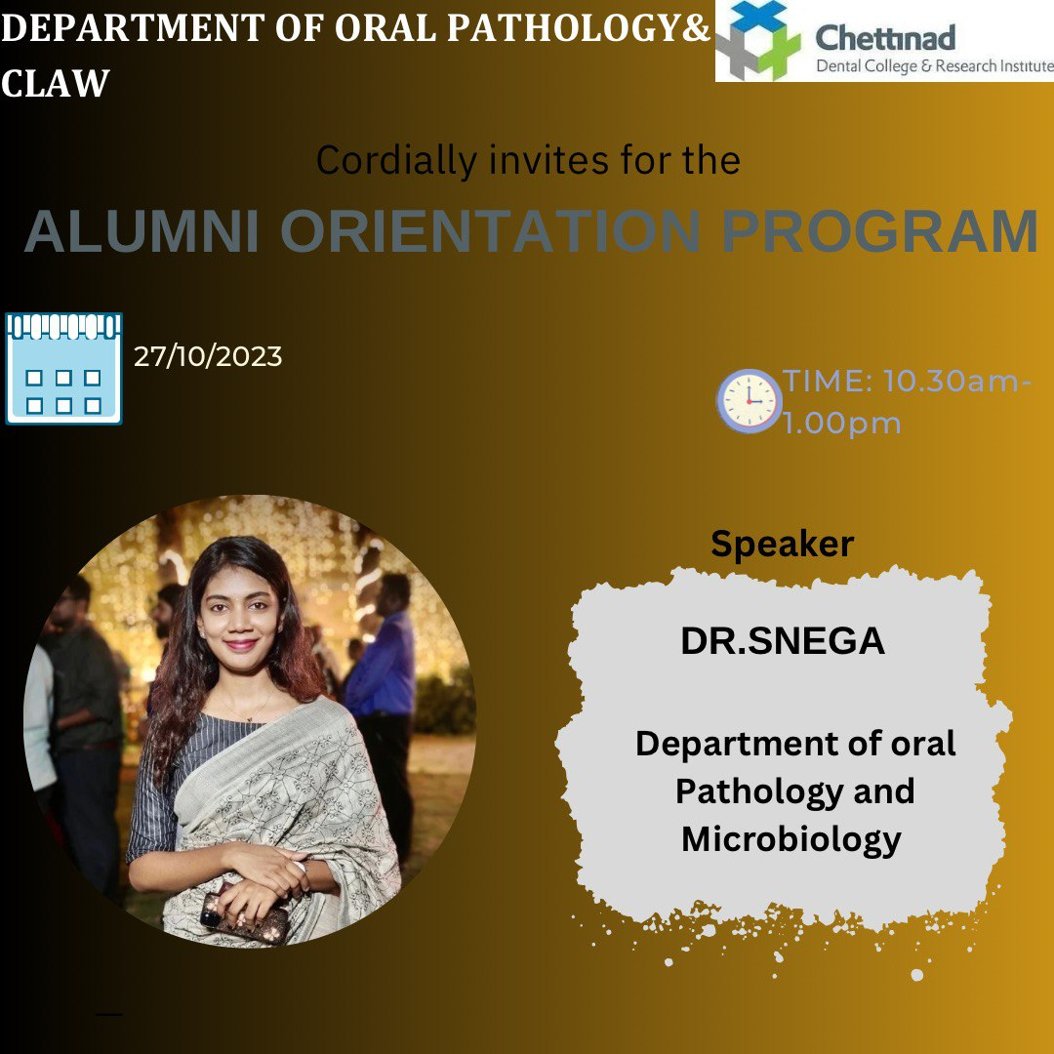

PROGRAM HIGHLIGHTS:

The program started by 8.45 am in Demo Hall-13- i.e. in I BDS lecture hall. All the ninety first year students were in the lecture hall. The speakers of the session were Dr. Snega, Dr. Priyadharshini, Dr. Naafia & Dr. Deepika. The introductory note was given by Dr.Snega. The first speaker was Dr. Deepika, shared her Under Graduate experience here in Chettinad dental college. She narrated how she enjoyed learning as well as acquired various skills here. The next speaker was Dr. Naafia, who was also an Undergraduate student in Chettinad dental college, shared her experiences- how all the staffs were more interactive and energetic, her interest in academics and sports, and what made her to pursue post-graduation here. Dr. Snega, who is currently working as senior lecturer here in Chettinad who was also an alumnus of CDCRI, shared her experiences as well how the institution changed her life academically and personally. Dr. Priyadharshini, an alumnus shared her video as a part of alumni orientation, told how Chettinad made her achieve academically to work in an international institution. Students of I BDS were interestingly asking questions and interacting with all alumni speakers. The session ended by 10.30 am.

PROGRAM CONSTRAINTS:
None

ACKNOWLEDGEMENT:

- Sincere Thanks to Mr. Manikandan- Information & Communication Technology department of the institution for their technical support
- Thanks to the administration & management of the institution for their support rendered

ATTENDANCE:

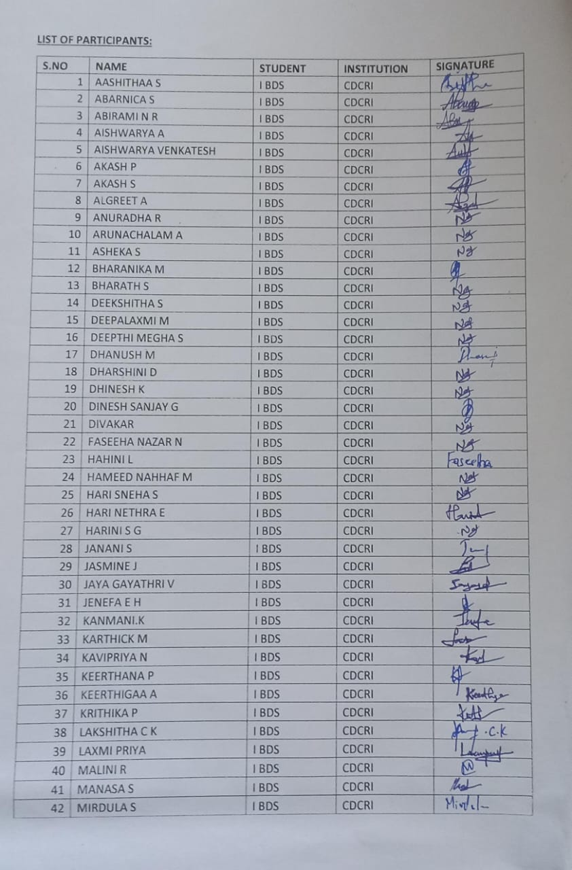

GEOTAGGED PHOTOS:

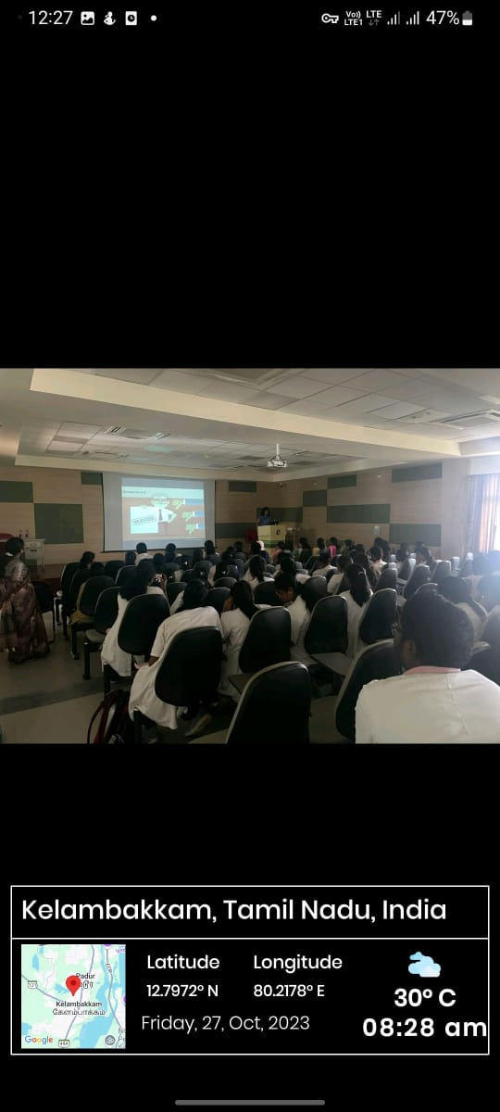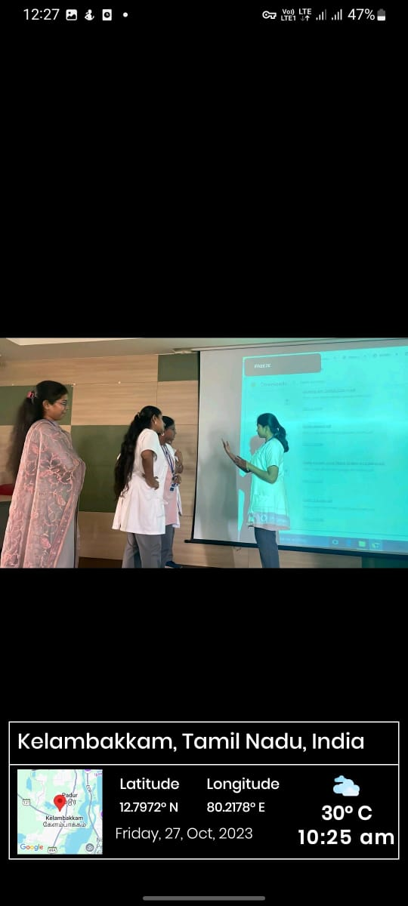

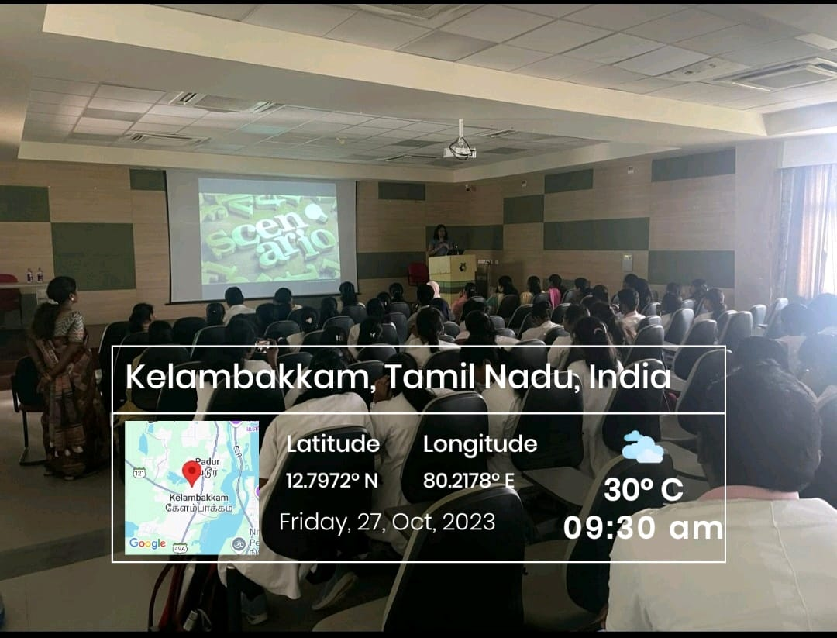

FEEDBACK ANALYSIS:

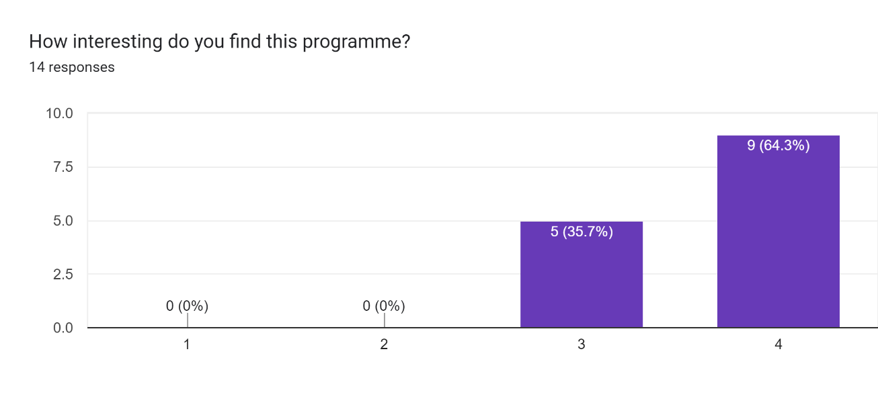

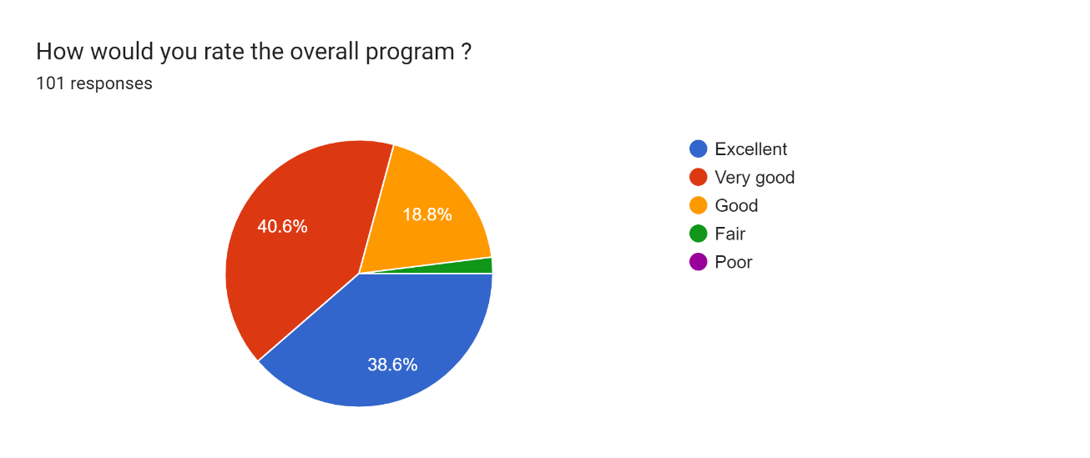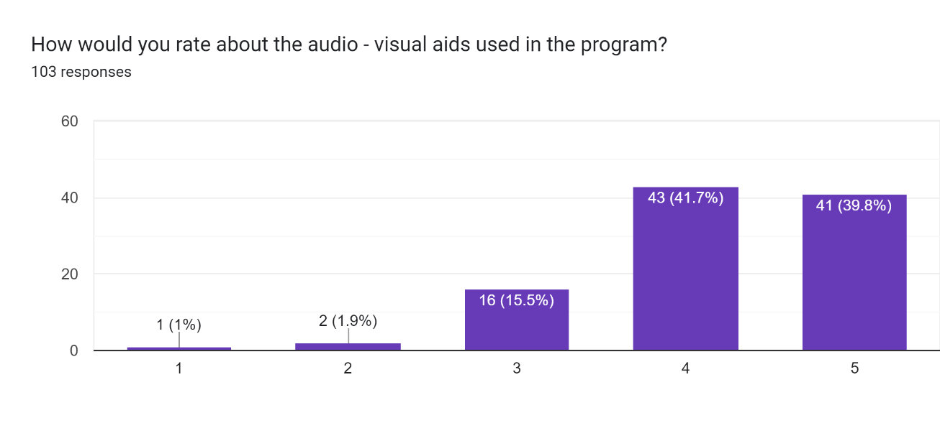

GUEST SPEAKER CERTIFICATE:

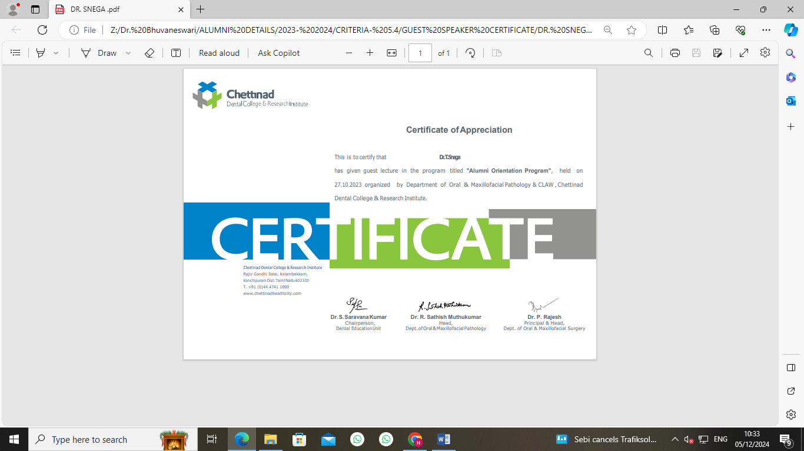

CIRCULAR

CLAW/2023/006 DATE: 20.11.2023

This is to inform that on behalf of CLAW and Department of Oral Pathology and Microbiology, organizing an Orientation Lecture and an Interactive session on “Impaction- Basics & Management” by Dr. Aachuthakrishnan

Date: 23.11.2024

Time: 10.30 am- 1.00 pm

Regards,

The President
CLAW

Copy To
Hon’ble Secretary- For Information
Principal
All Committee Members
Office File

REPORT OF THE PROGRAM:

Date: 23/11/2023
Time: 10.30 am- 01.00 pm
Venue: E Block, Lecture Hall- 14 & Department of Oral Surgery
No of Participants: 40

BROCHURE:

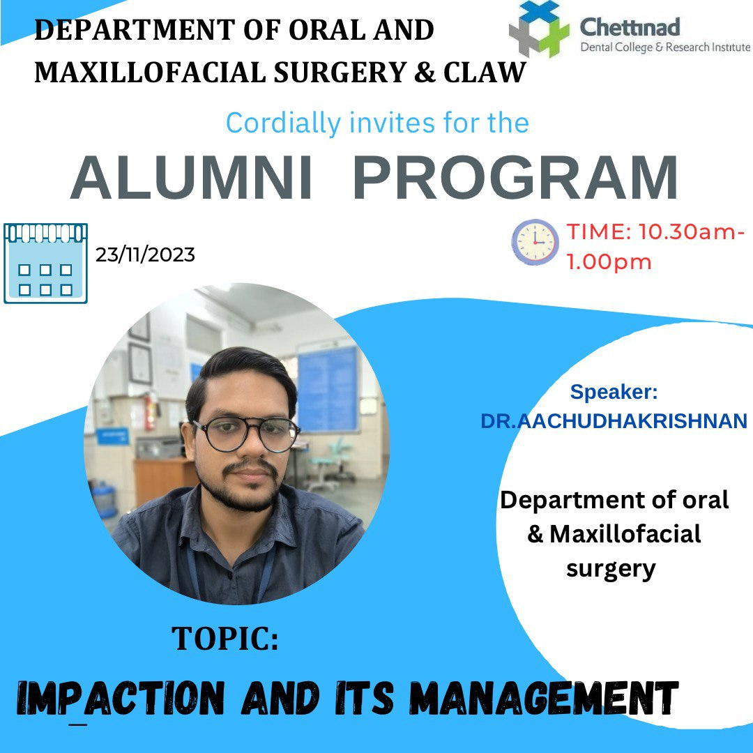

PROGRAM HIGHLIGHTS:

The event started by 10.30 am in the lecture hall- 14 with an introductory note from Dr. Ragavi. Dr. Aacchuthakrishnan was the key note speaker of the day. III BDS students were the participants. The speaker explained and discussed well about the impaction, its types based on clinical presentation and radiography. He also narrated well about what are the instruments required and various surgical extraction techniques to be followed in maxillary and mandibular impaction. He displayed few videos of Surgical extraction procedures during impaction removal. The students asked few questions in the techniques and the session ended by 1.00 pm.

ATTENDANCE SHEET:
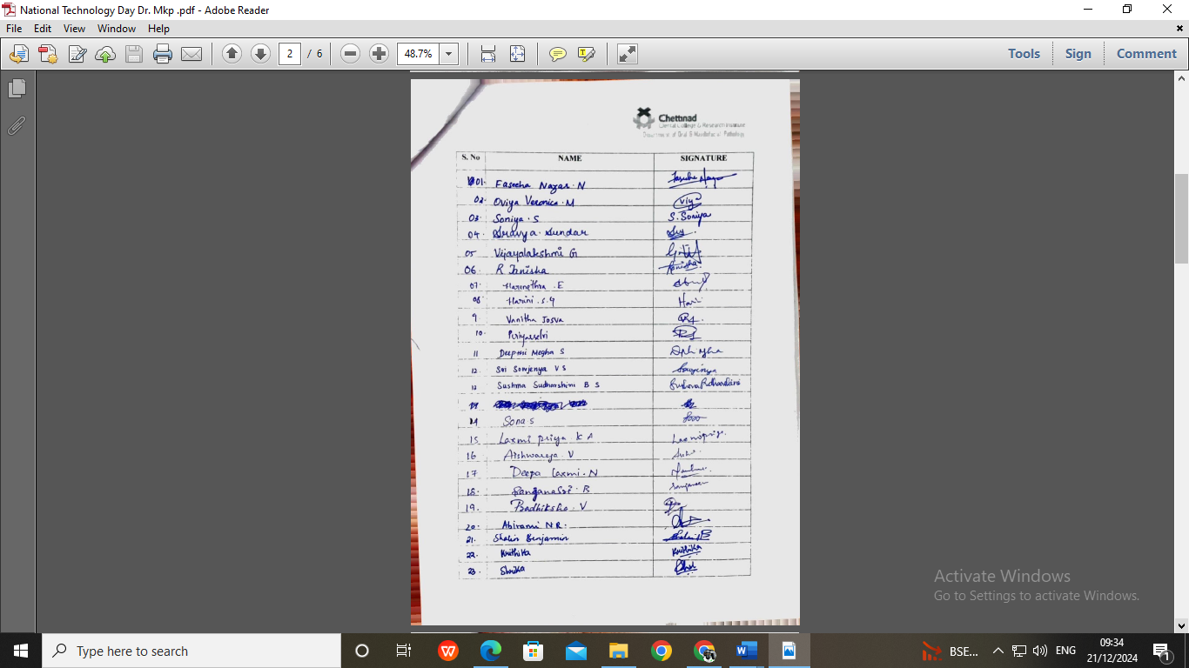

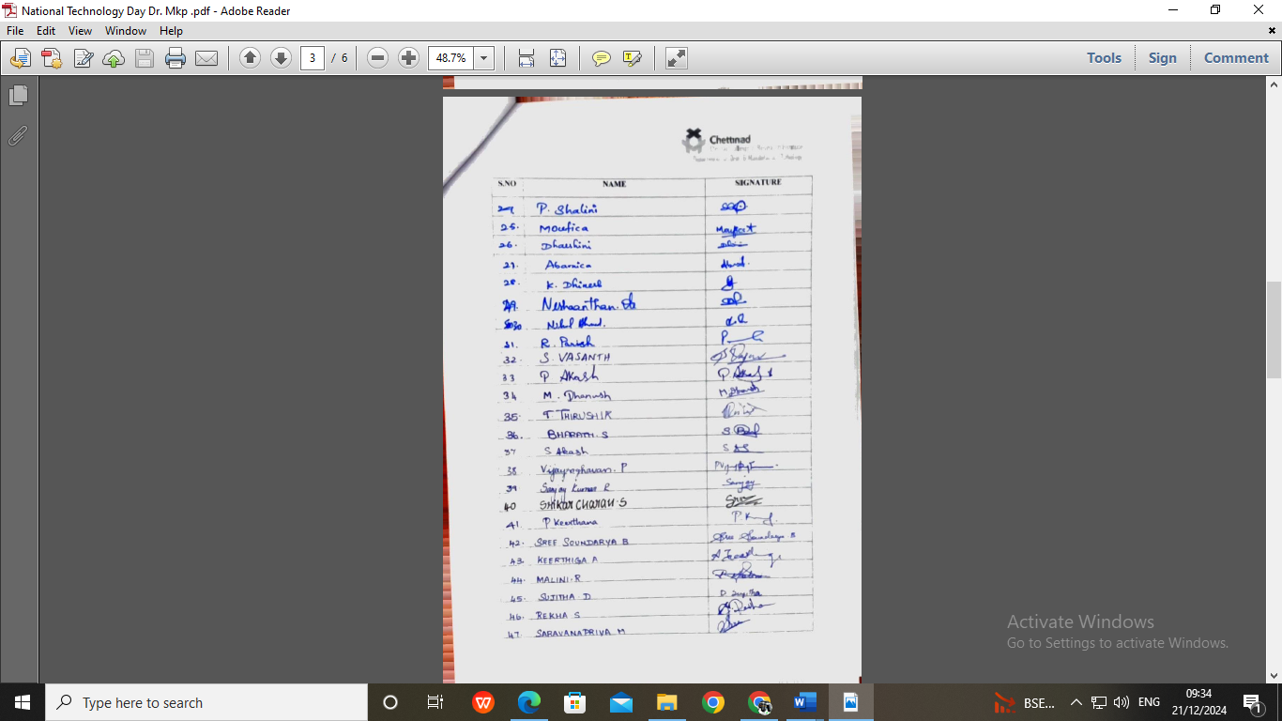

GEOTAGGED PHOTOGRAPHS:

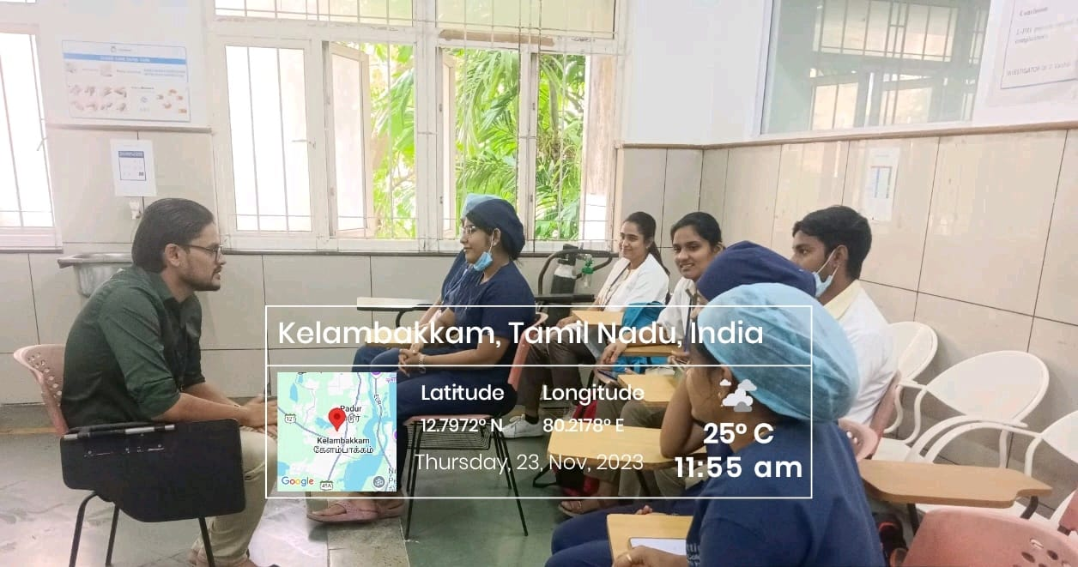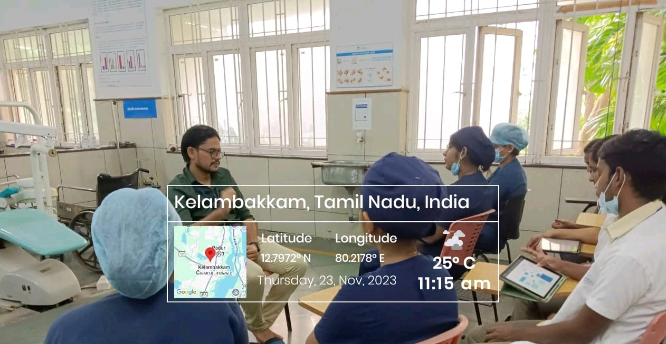
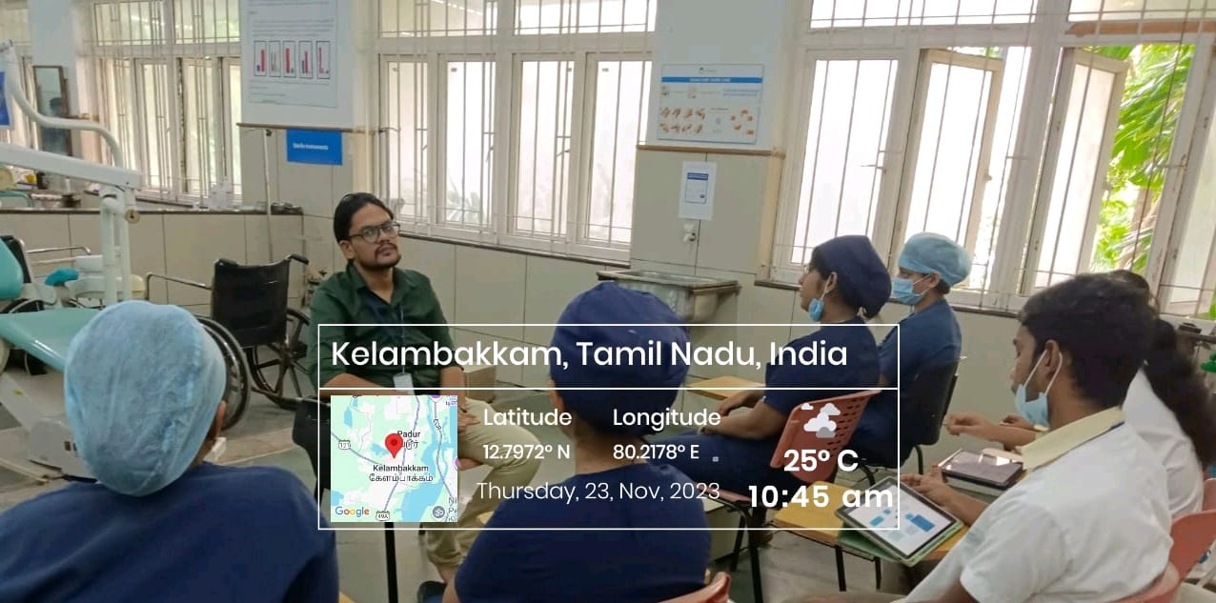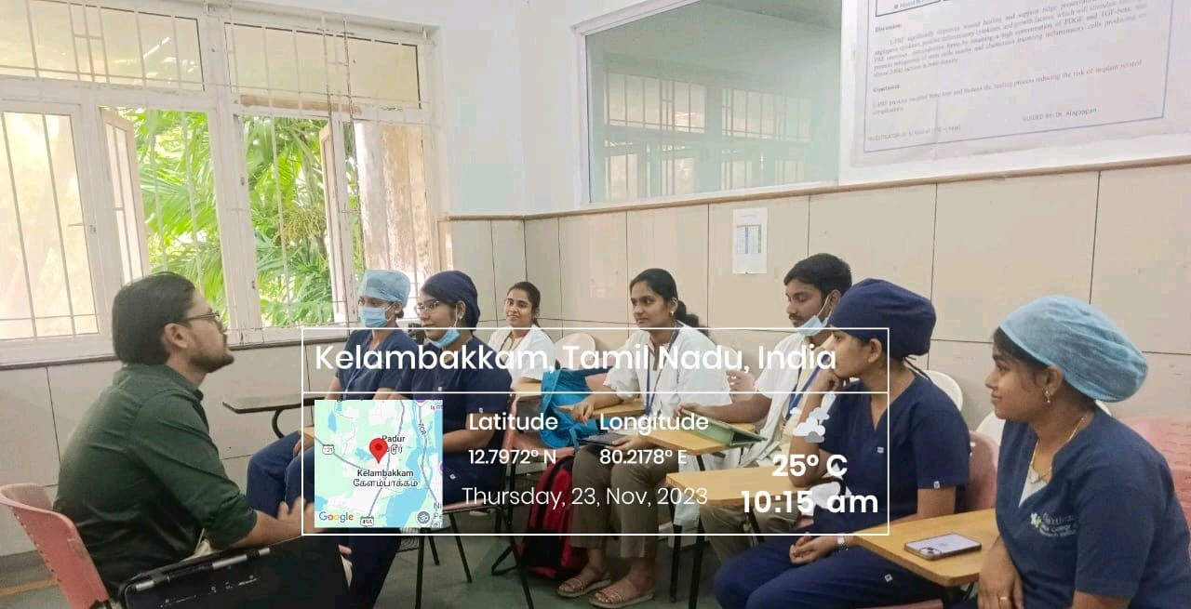

FEEDBACK ANALYSIS:

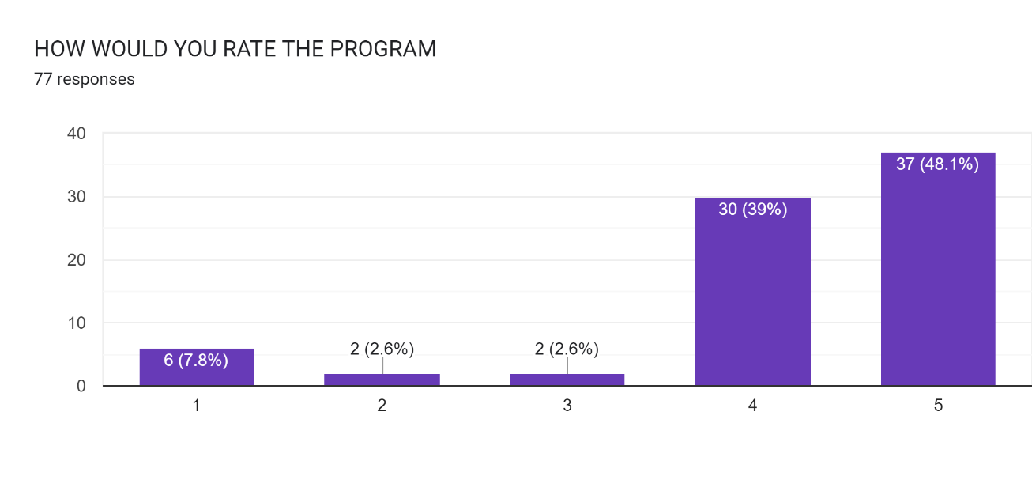

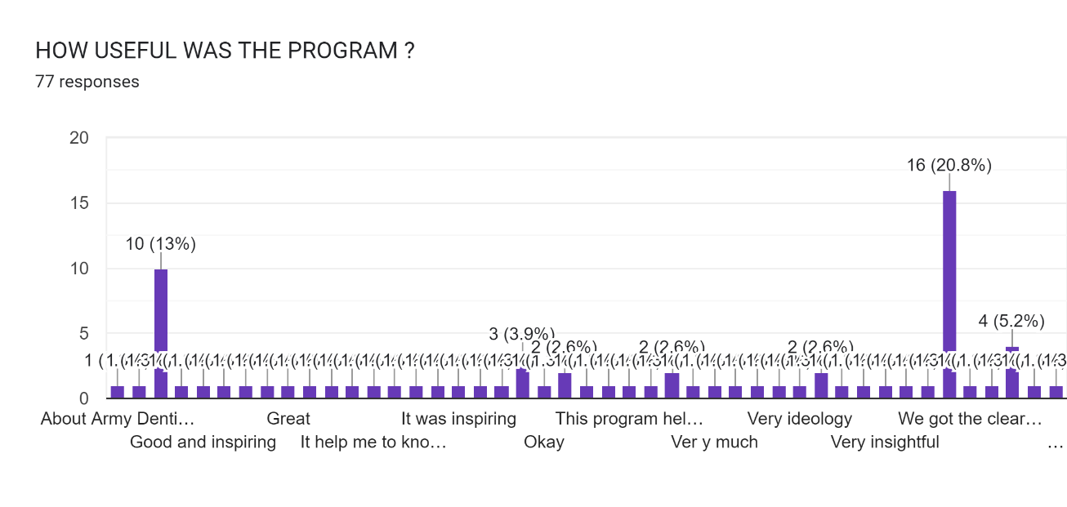

GUEST SPEAKER CERTIFICATE:

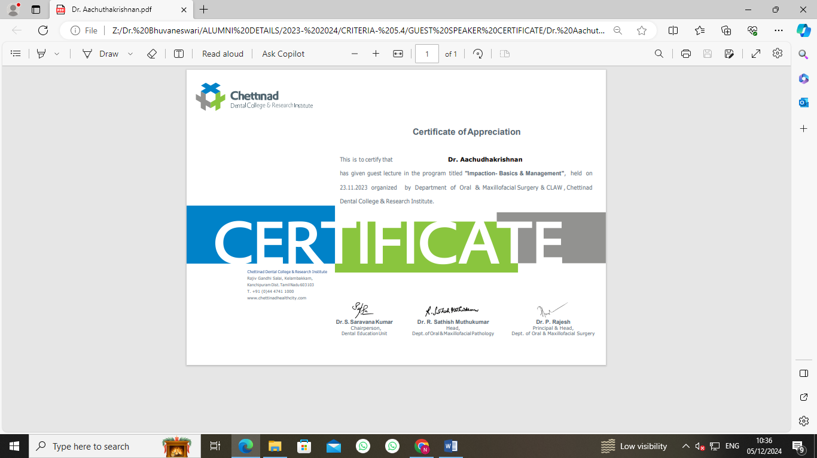

CIRCULAR

CLAW/2024/001 DATE: 09.01.2024

This is to inform that on behalf of CLAW and Department of Prosthodontics organizing Lecture and an Interactive session on “Medical Emergencies in Dentistry” by Dr. Ragavi on January 12th 2024 from 10.30 am- 12.00 pm.

Date: 12.01.2024

Time: 10.30 am- 12.00 pm

Regards,

The President
CLAW

Copy To
Hon’ble Secretary- For Information
Principal
All Committee Members
Office File

REPORT OF THE PROGRAM:

Date: 12/01/2024
Time: 08.30 am- 09.30 am
Venue: Department of Prosthodontics
No of Participants: 70

BROCHURE:

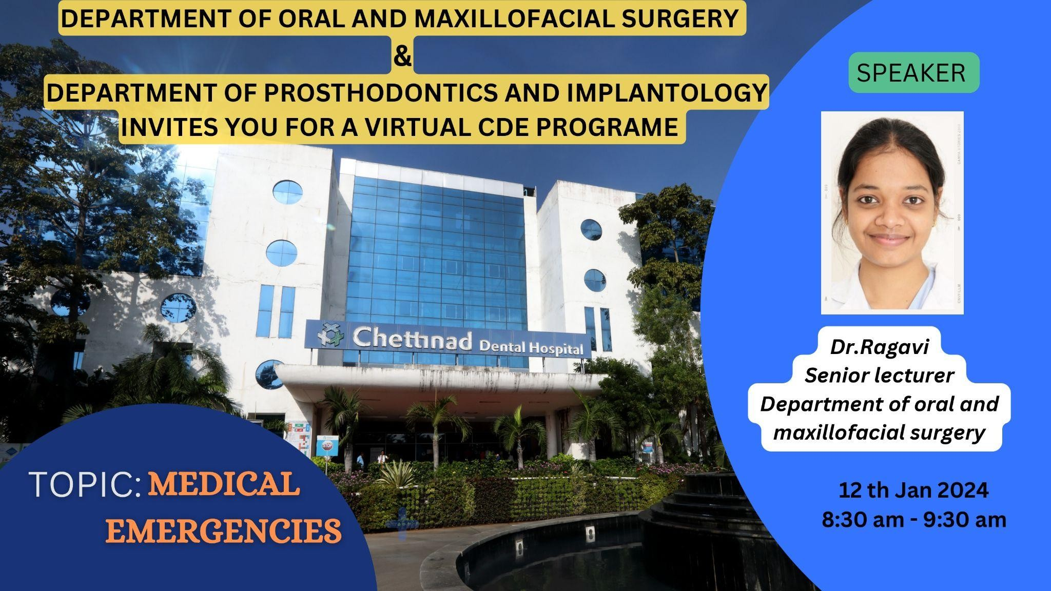

REPORT:
An CDE program on ‘MEDICAL EMERGENCIES’ was organized by the department of prosthodontics on 12th JANUARY 2024 from 8.30 am to 9.30 am. The Speaker of the program was Dr. Ragavi, Senior lecturer, Department of Oral and maxillofacial surgery, Chettinad dental college and research institute. The program included undergraduate students. Lecture on medical emergencies that might occur in clinic setup and management of these emergencies were discussed in the lecture. The important measures, drugs required for management all were discussed. The question and answer session was done and the queries were explained clearly. Material on rehabilitation of management of medical emergencies was circulated to the participants. A feedback form was circulated and the responses were noted for further program improvement. An E-certificate was provided for the participants.

ATTENDANCE SHEET:

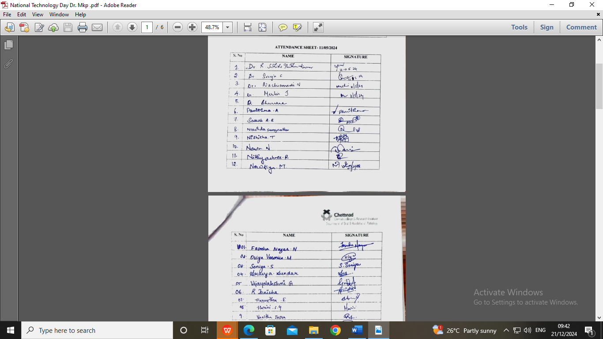

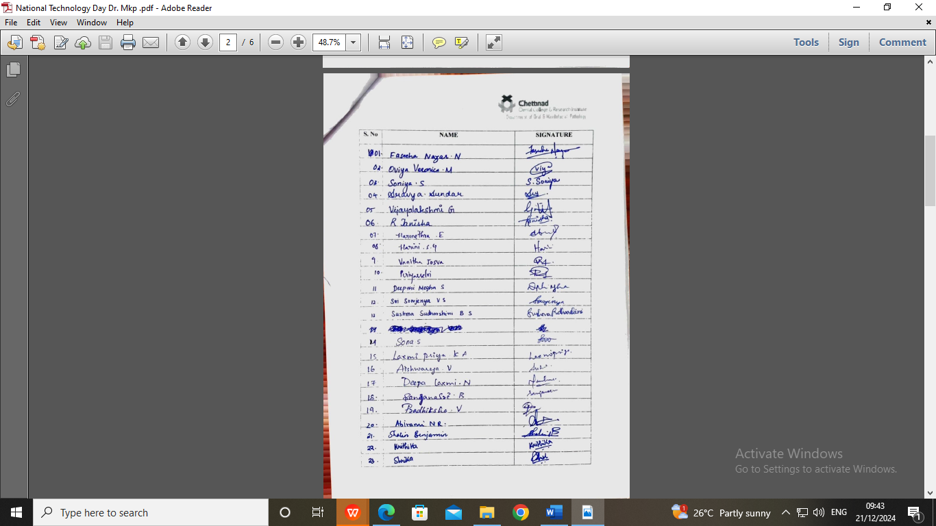

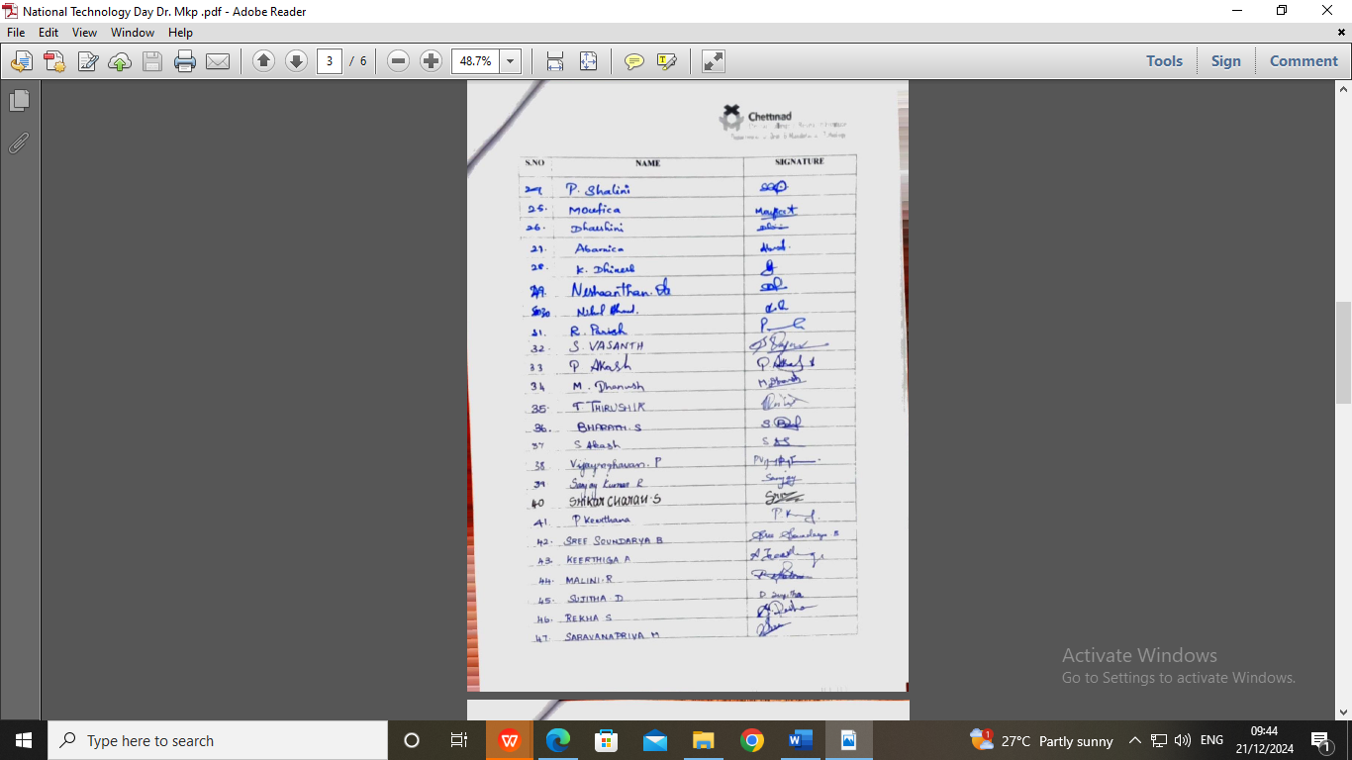
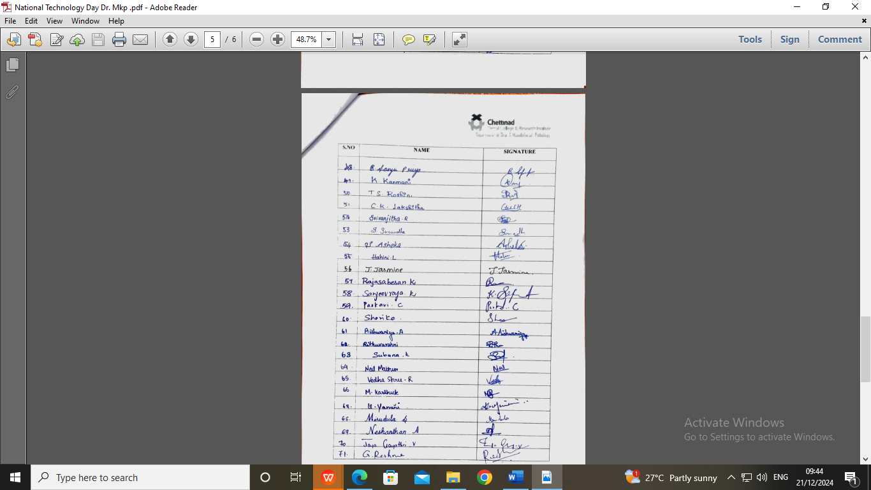

GEOTAGGED PHOTOGRAPHS:

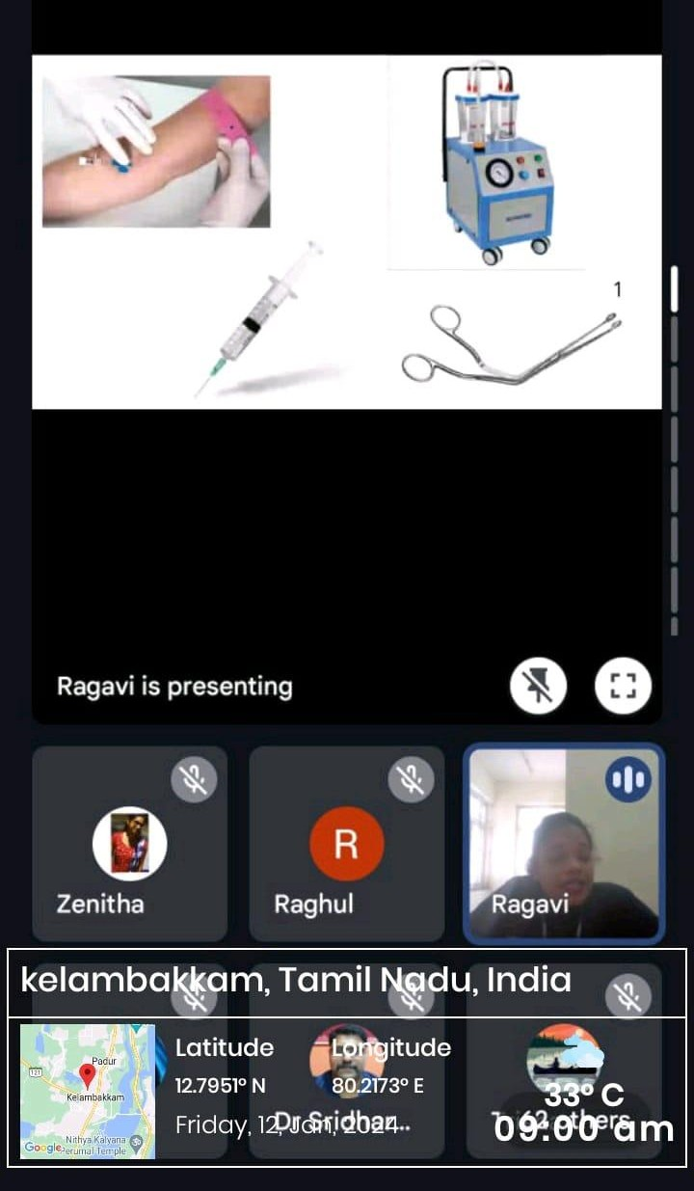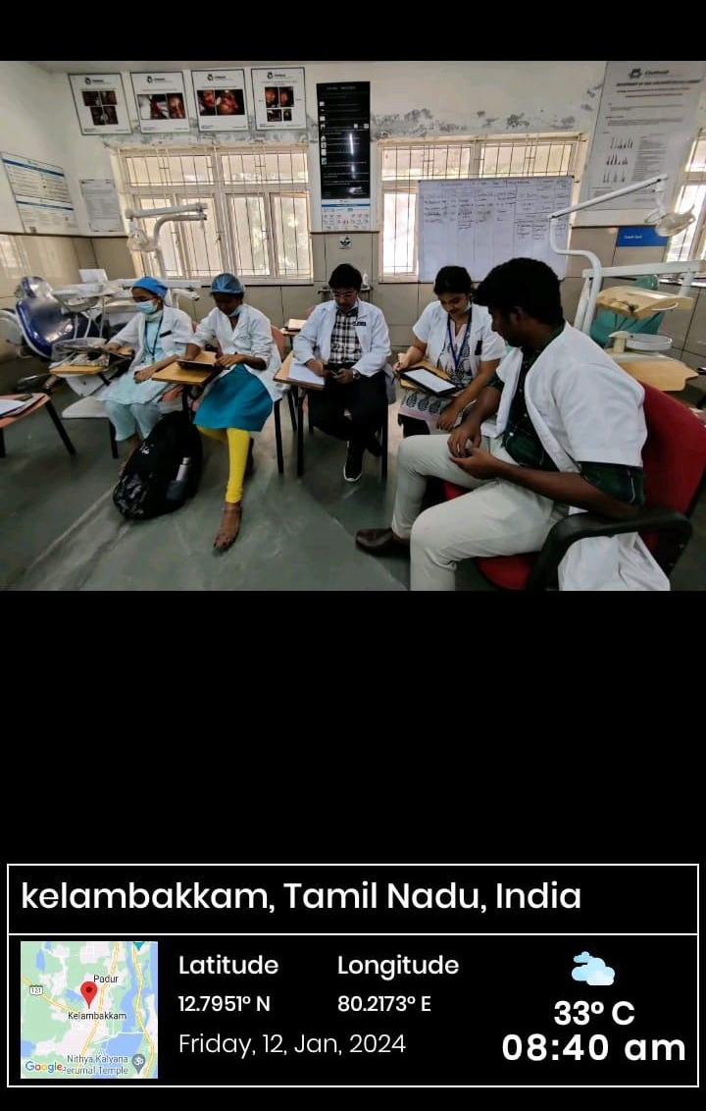
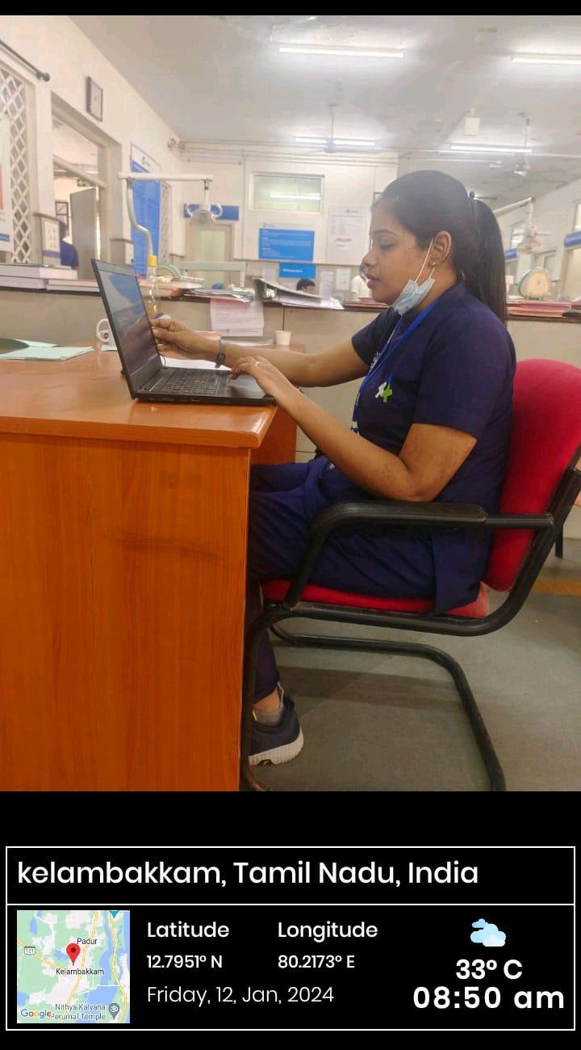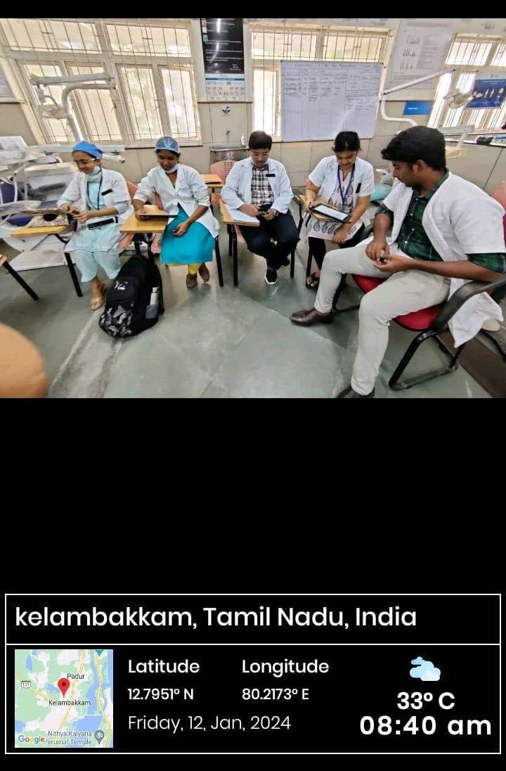

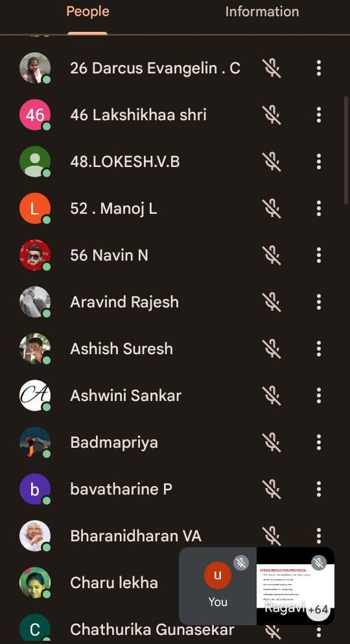

FEEDBACK:
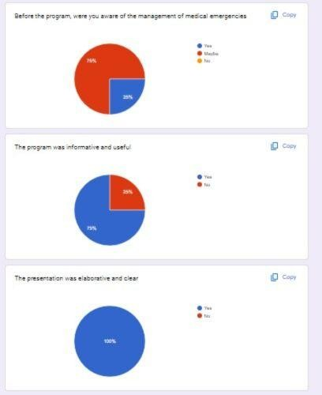

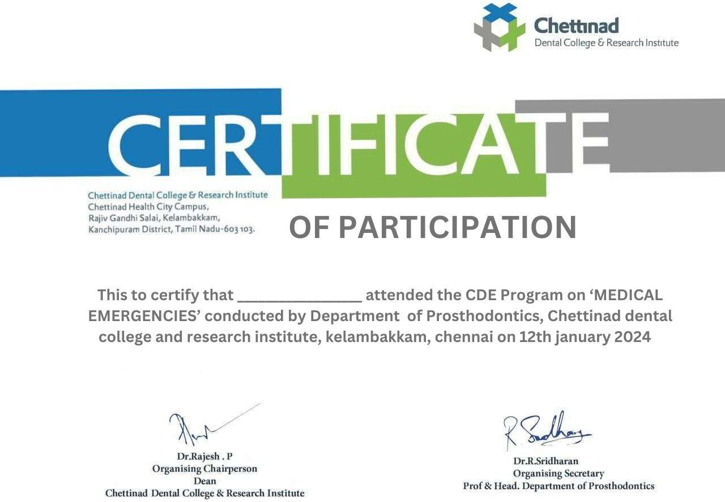
CERTIFICATE:

CIRCULAR

CLAW/2024/002 DATE: 09.01.2024

This is to inform that on behalf of CLAW and Department of Prosthodontics organizing Lecture and an Interactive session on “Overdentures in Prosthodontics” by Dr. Mayank Kumar Parakh on January 12th 2024 from 10.30 am- 12.00 pm.

Date: 12.01.2024

Time: 10.30 am- 12.00 pm

Regards,

The President
CLAW

Copy To
Hon’ble Secretary- For Information
Principal
All Committee Members
Office File

REPORT OF THE PROGRAM:

Date: 12/01/2024
Time: 08.30 am- 09.30 am
Venue: Department of Prosthodontics
Zoom Link: https://us06web.zoom.us/j/87133532831?pwd=yMfUXqy5doxNlTtujHVmU8F3BdJVeP.1

No of Participants: 42

BROCHURE:

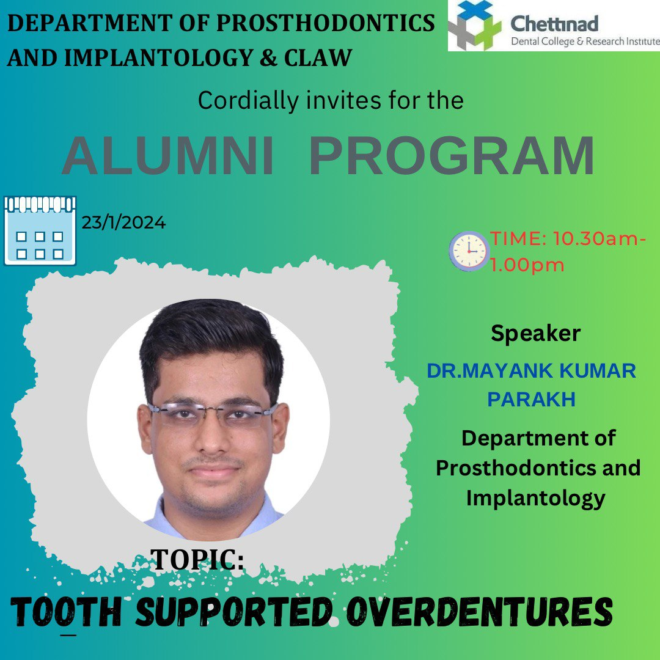

PROGRAM HIGHLIGHTS:

The session started by 10.30 am through Zoom application. Dr. Sowmiya gave an Introductory note for the speaker. Dr. Eazhil was moderator of the session Dr. Mayank started the session with introduction on overdentures. He narrated in nutshell what are the available overdentures in prosthodontics and described in detail about tooth supported overdentures. The session includes definition, classification, advantages, disadvantages, requirements, copings- its types; advantages and disadvantages of each types of tooth supported dentures. He also insisted the importance of case/patient selection for overdentures and also notified tooth supported overdentures are economical and patient friendly. He shows cased few cases he had done tooth supported overdentures in his private practice. The session was very interesting and knowledgeable. It ended by 1.45 pm after few queries and discussion by Dr. Eazhil and Dr, Mayank.

ATTENDANCE SHEET:

GEOTAGGED PHOTOS:

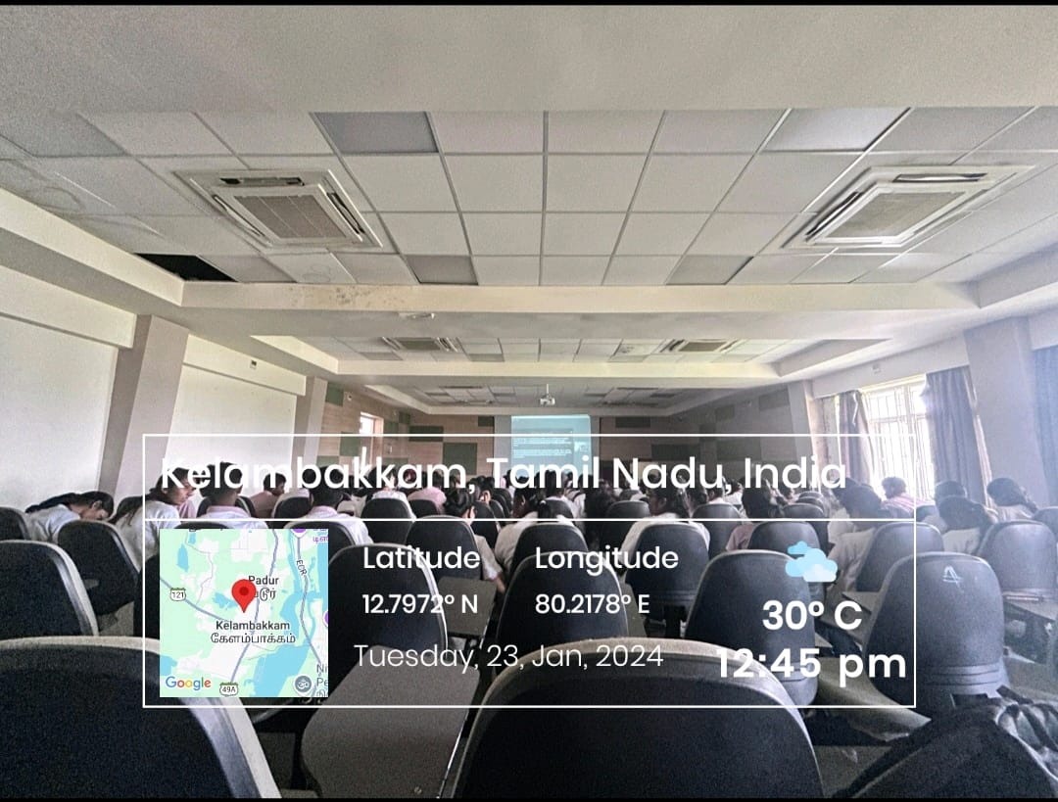

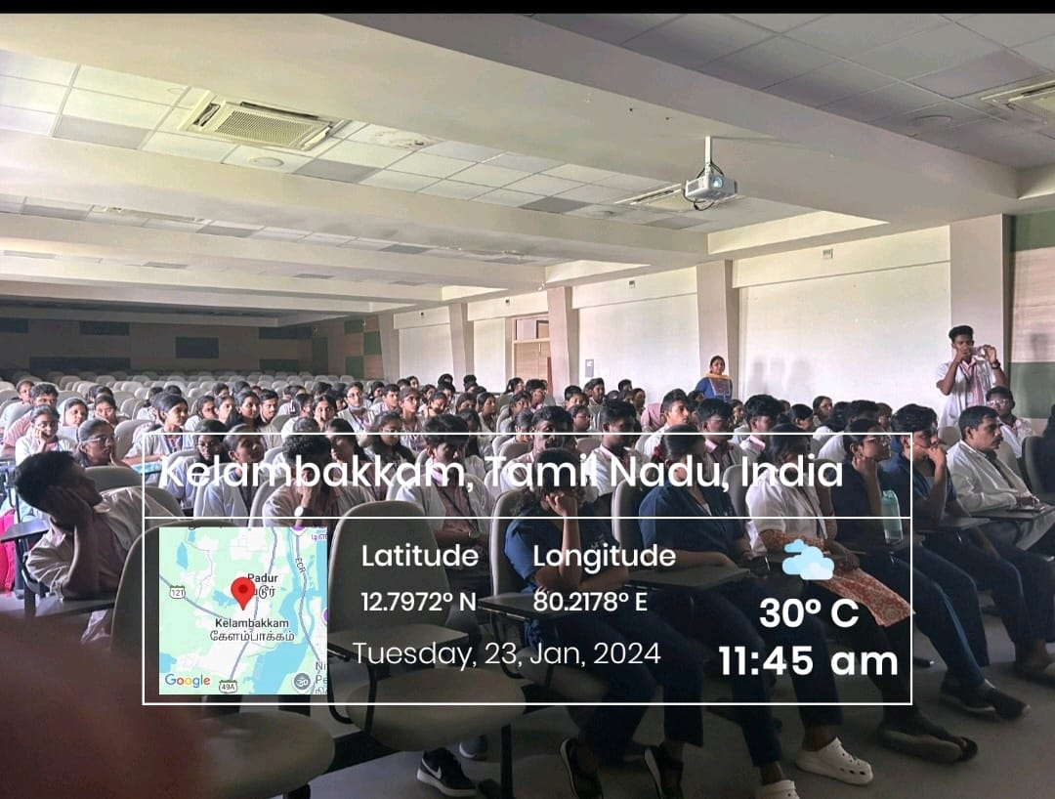

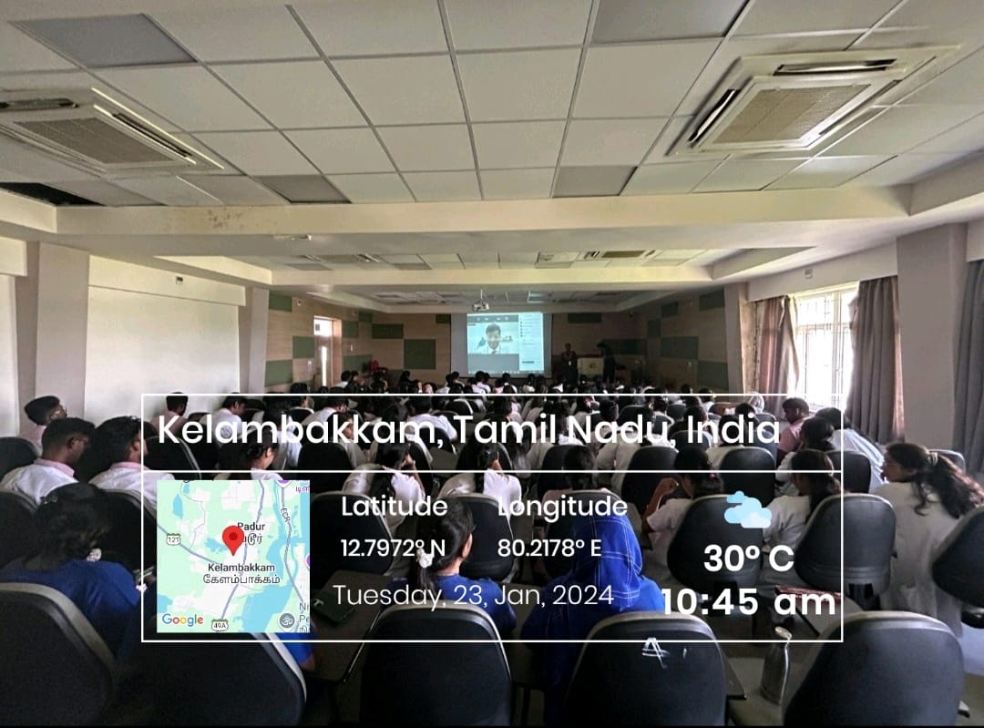

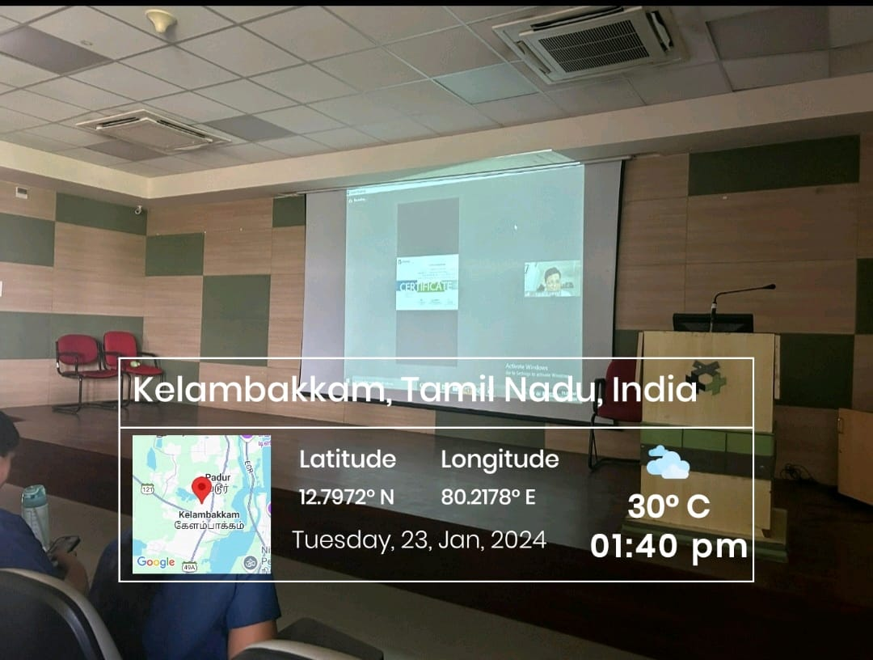

FEEDBACK ANALYSIS:

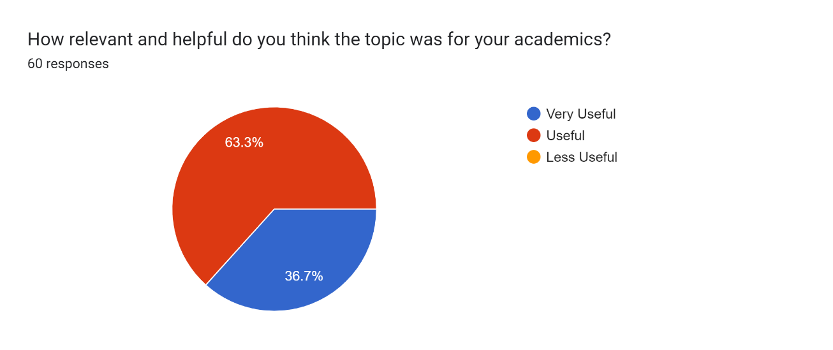

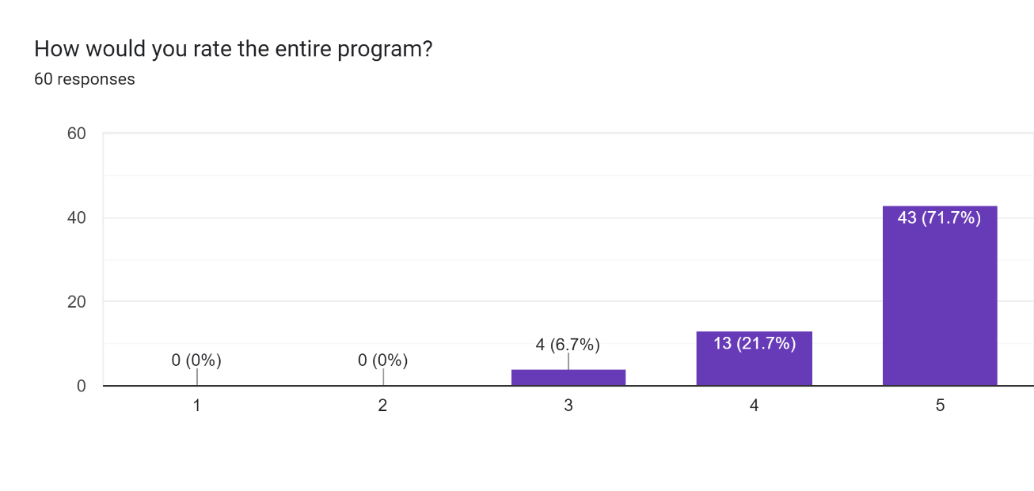

GUEST SPEAKER CERTIFICATE:

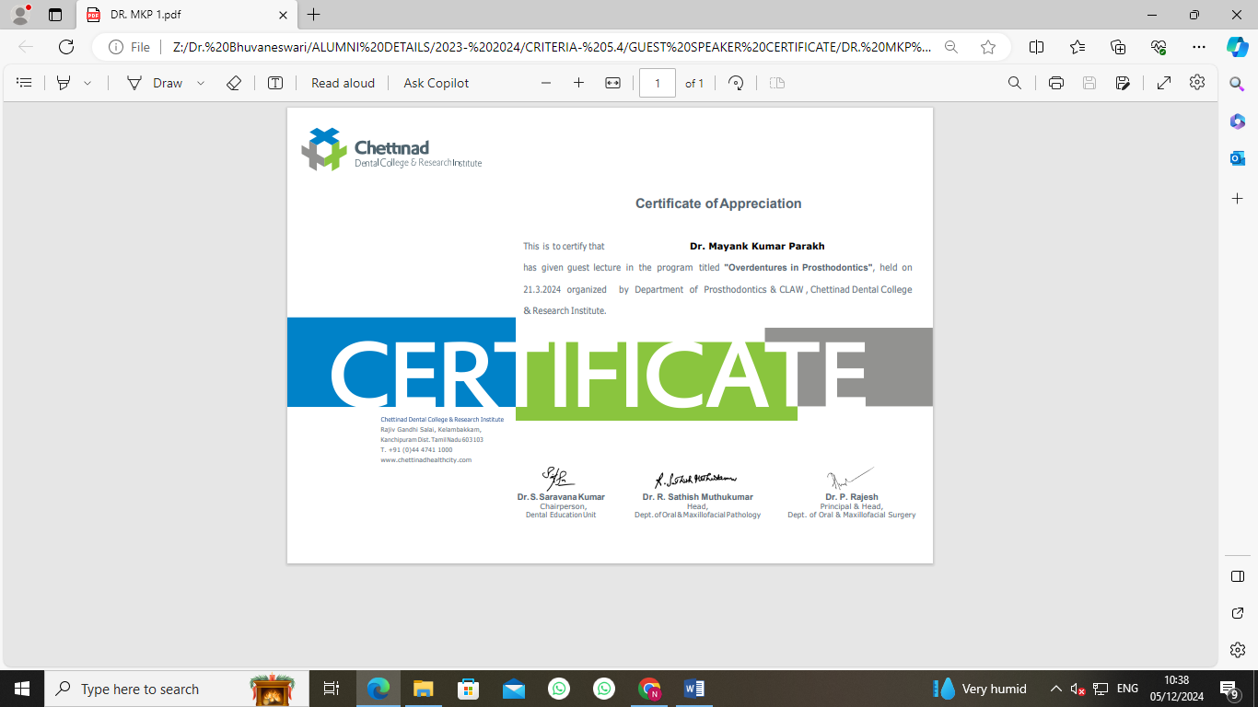

CIRCULAR

CLAW/2024/003 DATE: 10.04.2024

This is to inform that on behalf of CLAW, Department of Periodontics and Institutional Innovation Council, CDCRI organizing Lecture and an Interactive session on “Roadmap For Successful Dental Clinic Establishment” by Dr. Vidhya on April 25th and 26th 2024 from 90.30 am- 03.30 pm.

Date: 25th and 26th April, 2024

Time: 09.30 am- 3.30 pm

Regards,

The President
CLAW

Copy To
Hon’ble Secretary- For Information
Principal
All Committee Members
Office File

REPORT OF THE PROGRAM:

Date: 25.04.2024 & 26.04.2024
Time 09.00AM- 3.30 PM
Venue: E- Block Lecture Hall- 14 & Dept of Periodontics
No of Participants: 80

BROCHURE:

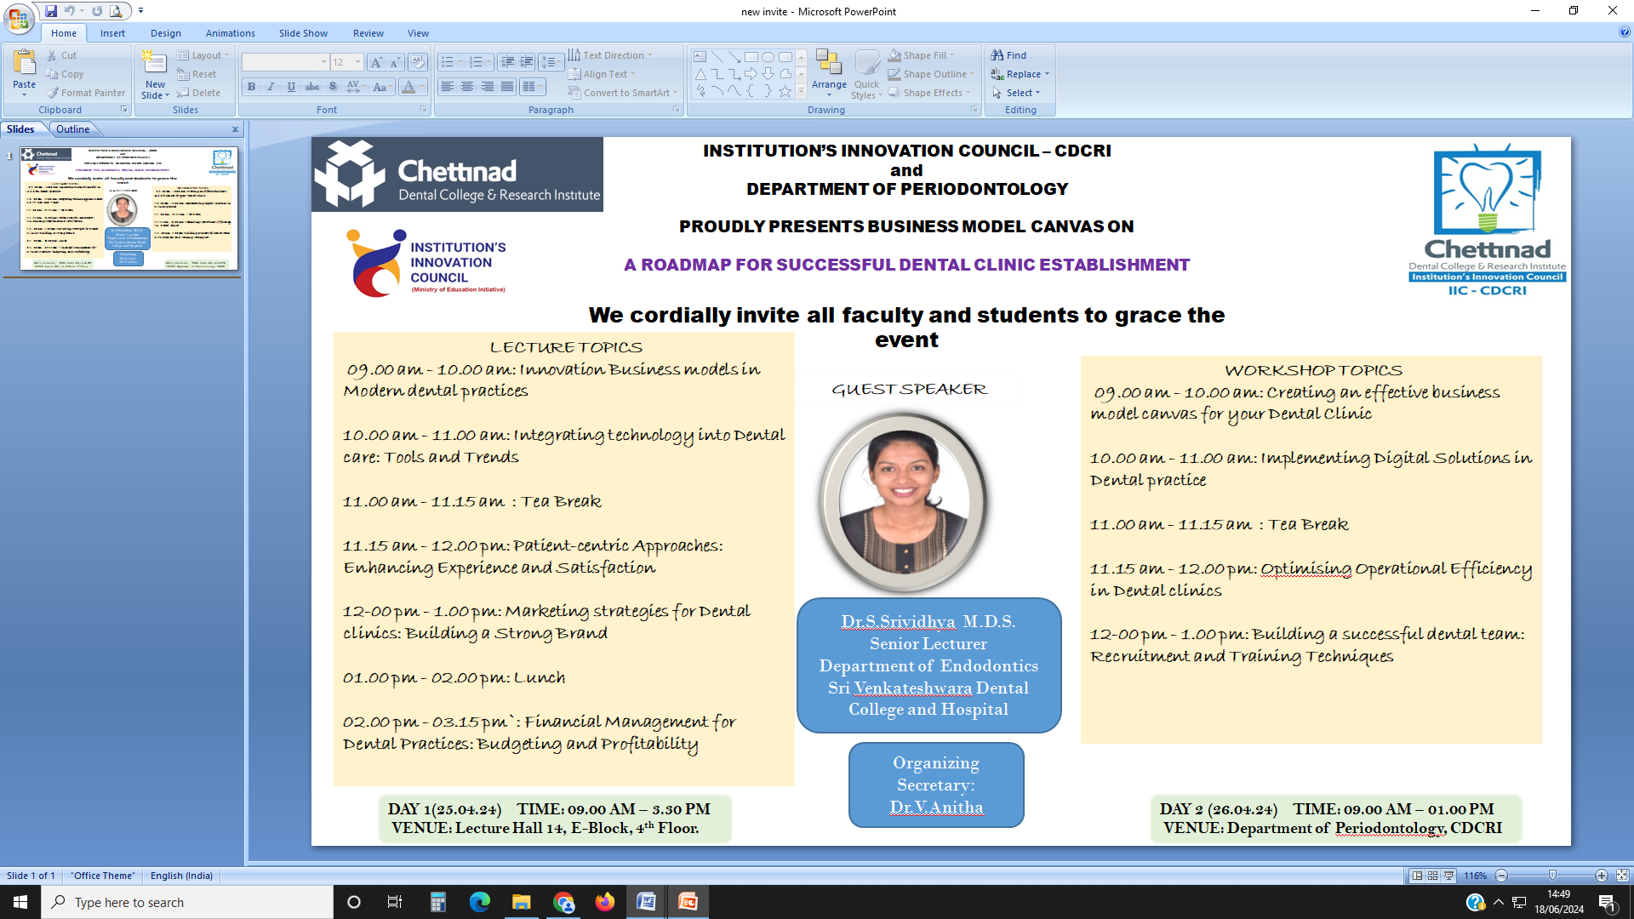

SESSION DETAILS
Title of session/ program | “Roadmap For Successful Dental Clinic Establishment”
Date | From: 25.04.2024 | To:26.04.2024
Time | From: 09.00 am -03.30 pm | From: 09.00 am -01.00 pm
Duration of the activity (in minutes) | 630 minutes
Activity category | Self Driven activity
Theme of activity | “Workshop on Business Model Canvas "
Mode of delivery | Offline
EXPERT / SPEAKER DETAILS
Name of Speaker | Dr.S.Srividhya M.D.S
Designation | Senior Lecturer , Department of Endodontics
Organization | Sri Venkateshwara Dental College, Chennai
Brief about Expert/Speaker: | Dr. S. Srividhya, is a passionate mentor and dedicated clinician. She graduated with the Best Outgoing Award in 2018 from Sri Venkateswara Dental College and Hospital and completed her post-graduation at Chettinad Dental College and Research Institute in 2022. During her academic journey, Dr. Srividhya has been recognized with several accolades, including the 'Emerging Star Award' from the Conservative and Endodontics Association of Tamil Nadu and the 'Young Scientist Award' at the 4th International Conference on Dentistry and Oral Health. With a strong background in academic achievements and clinical excellence, Dr. Srividhya possesses a keen interest in guiding aspiring dental professionals on the roadmap to establishing successful dental clinics. Her session on the Roadmap For Successful Dental Clinic Establishment blends practical insights with scholarly rigor, drawing from her extensive experience in academia and clinical practice. Dr. Srividhya's ability to integrate theoretical knowledge with practical strategies makes her a sought-after speaker in the field of dental education and practice management.
OUTCOME OF ACTIVITY
Objectives | 1.Understand the essentials of dental clinic setup  2. Financial planning and management  3.Clinic design and equipment  4.Staffing and Human resources  5.Marketing and Patient Acquisition  6.Operational efficiency and patient care
Outcomes | 1. Comprehensive Knowledge of clinic establishment  2. Effective Financial Management  3. Optimized clinic Design  4. Efficient and motivated team  5. Successful Marketing Strategies  6. Operational Excellence
Key highlights | 1.Interactive workshops and Seminars  2.Real-World case studies  3.Networking opportunities  4.Resource materials and Templates  5. Personalized Mentorship  6. Latest trends and Technologies
PARTICIPANTS DETAILS
No. of Student Participants | 75
No. of Faculty Participants | 5

ATTENDANCE SHEET:

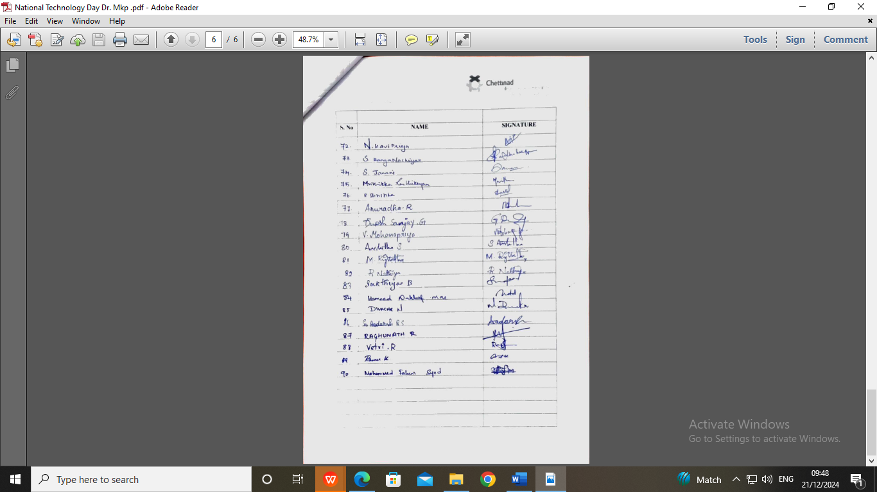

GEOTAGGED PHOTOGRAPHS:

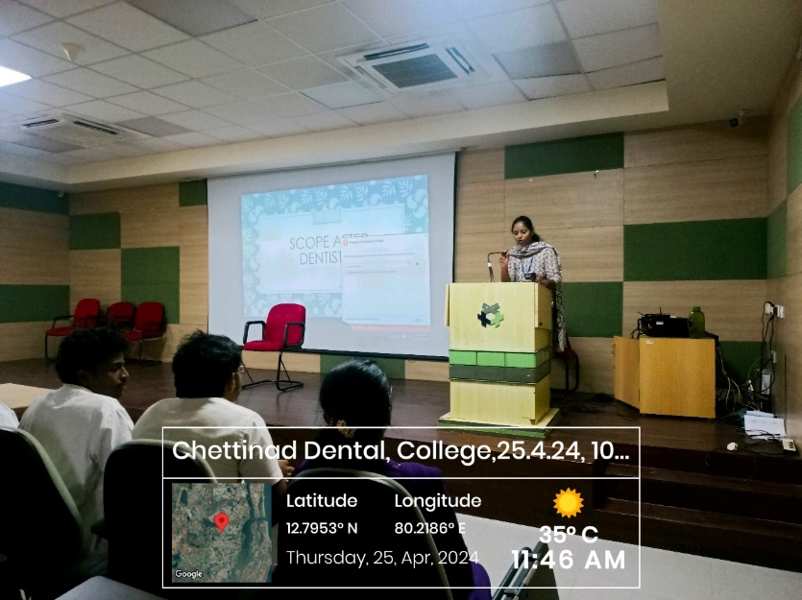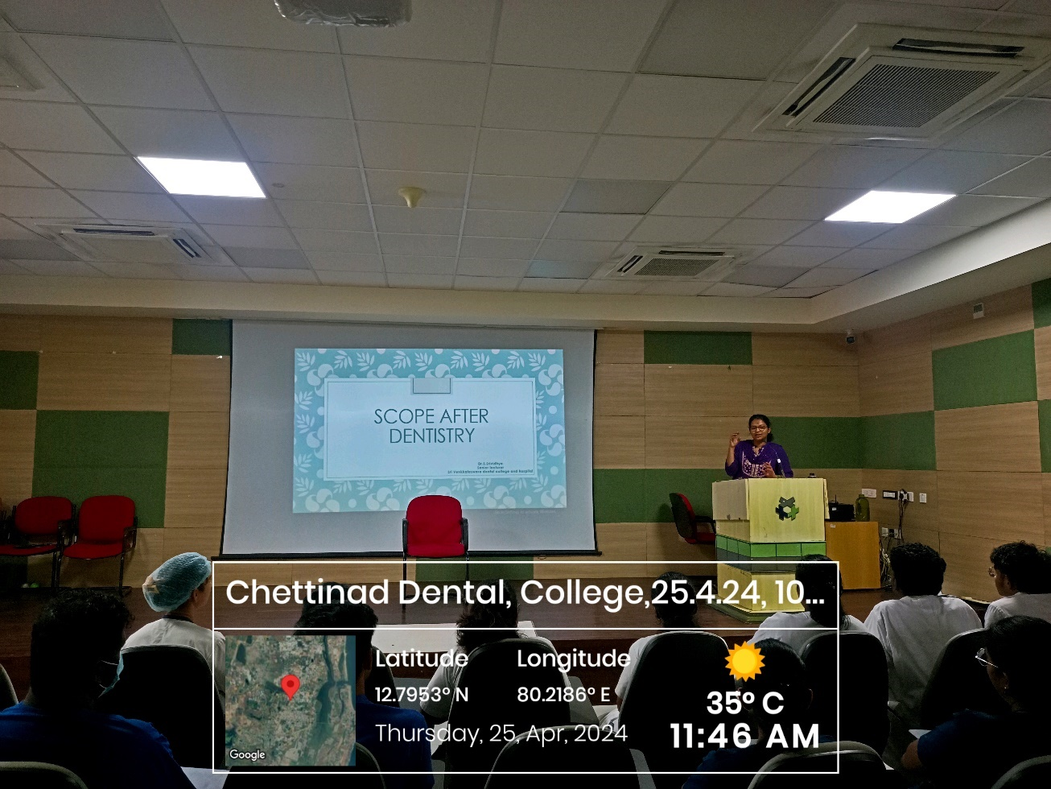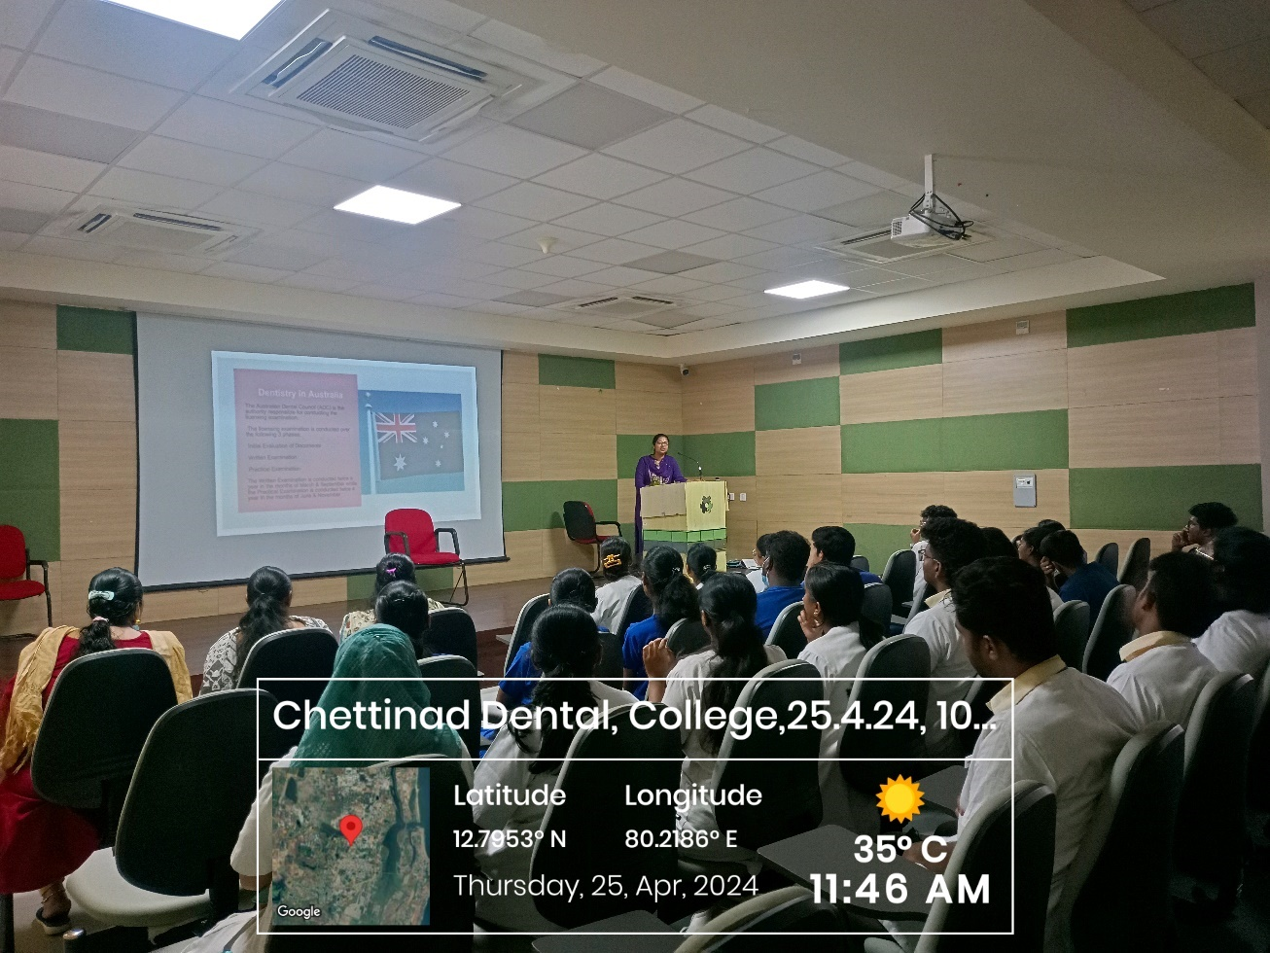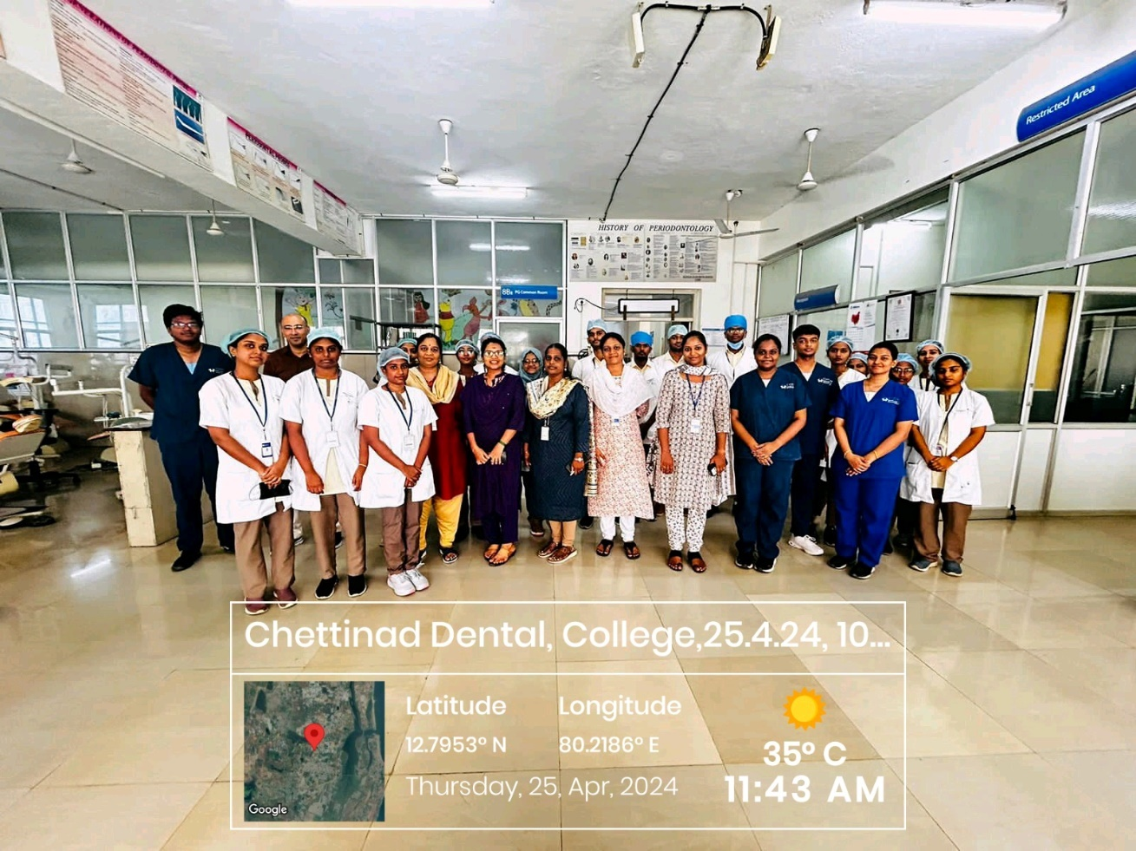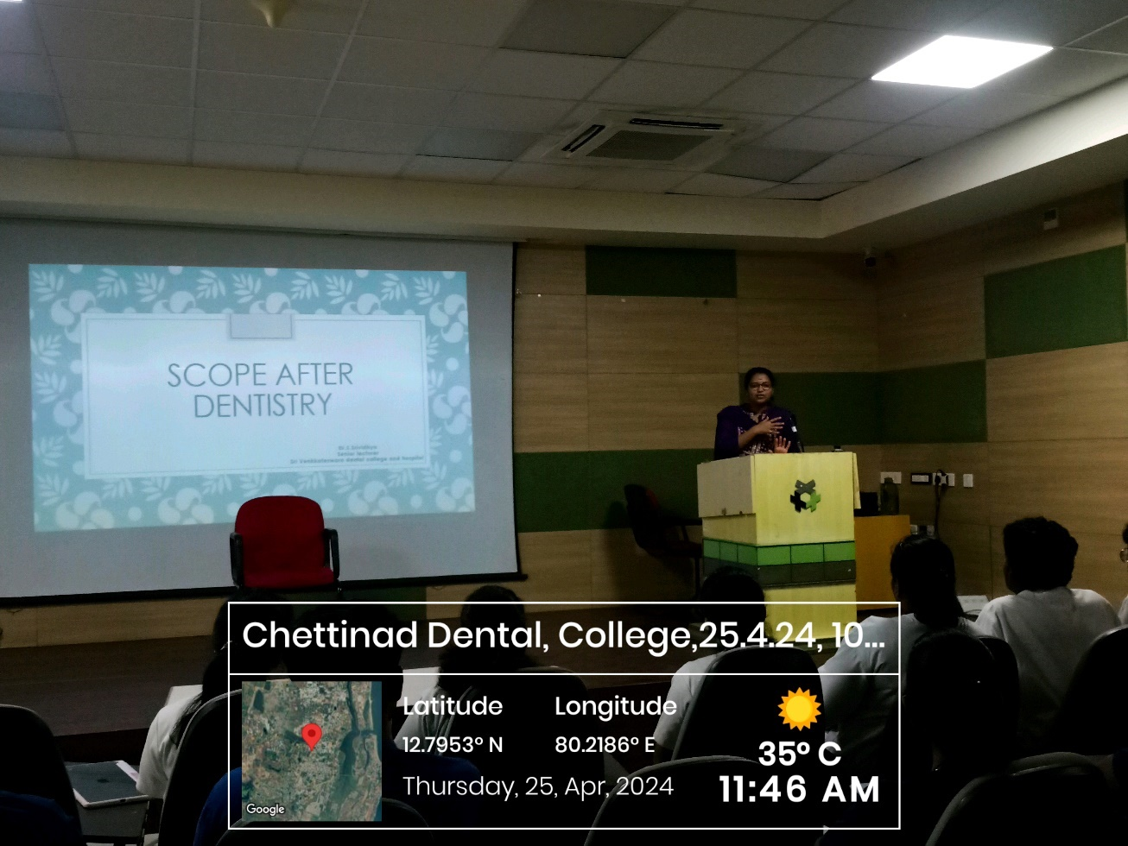

FEEDBACK:

SPEAKER CERTIFICATE:

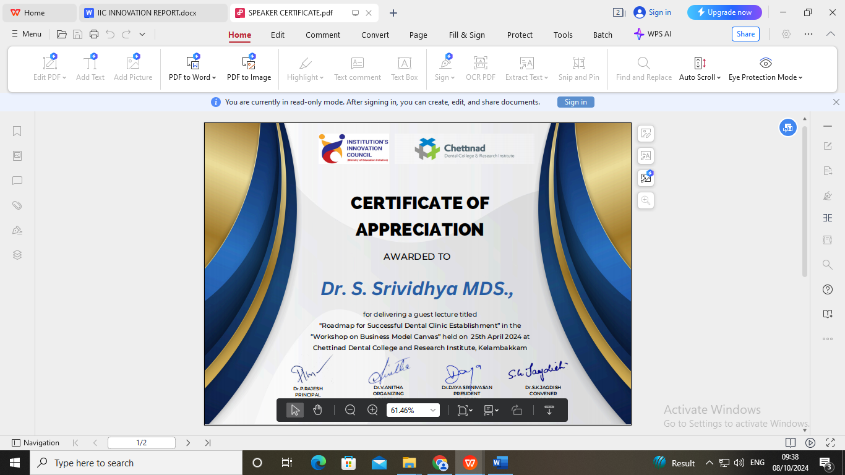

CIRCULAR

CLAW/2024/004 DATE: 16.04.2024

This is to inform that on behalf of CLAW and Department of Oral Pathology and Institutional Innovation Council, CDCRI organizing Lecture and an Interactive session on “IPR, Start Ups & Innovative Ideas” by Dr. Gokulakannan on 06.05.2024- 09.05.2024, from 10.30 am- 12.00 pm.

Date: 06.05.2024- 09.05.2024

Time: 9.00 am- 3.30 pm

Regards,

The President
CLAW

Copy To
Hon’ble Secretary- For Information
Principal
All Committee Members
Office File

REPORT OF THE PROGRAM:

Date: 06.05.2024 & 09.05.2024
Time 09.00AM- 3.30 PM
Venue: Academic Block- Lecture Hall
No of Participants: 283

BROCHURE:

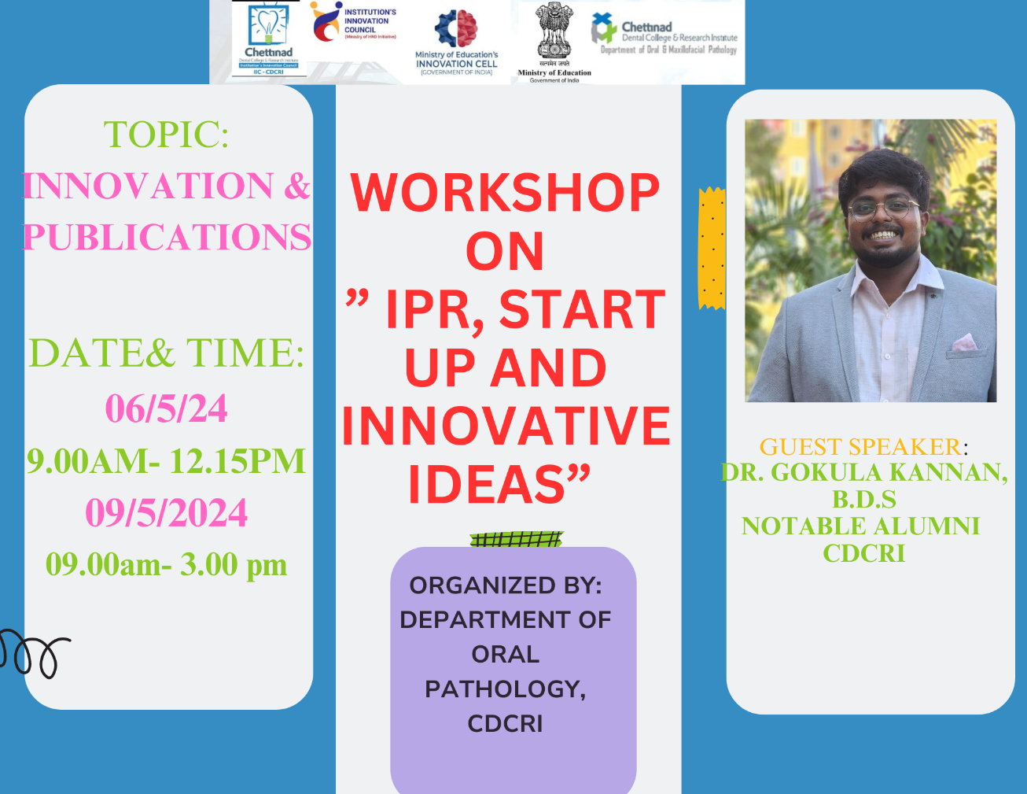

ACTIVITY REPORT- INSTITUTIONAL INNOVATION COUNCIL
IIC- CHETTINAD DENTAL COLLEGE & RESEARCH INSTITUTE
SESSION DETAILS
Title of session/ program | WORKSHOP ON INTELLECTUAL PROPERTY RIGHTS, INNOVATIVE IDEAS AND START UP
Date : | 06.05.2024 | 09.05.2024
Time | From: 07.45am To: 12.15 PM | From: 07.45am To: 03.15 PM
Duration of the activity (in minutes) | 15 HOURS
Activity category | Self -Driven activity
Theme of activity (Select one) | How to file patents, What are innovative ideas and Start Ups?
Mode of delivery | Offline
EXPERT / SPEAKER DETAILS
Name of Speaker | Dr. Gokulakannan BDS.,
Designation | Clinical Practitioner
Organization | Chettinad Hospital & Research Institute,
Brief about Expert/Speaker:  (max 100 words) | Dr. Gokulakannan is a notable alumnus of Chettinad dental college and research institute who was known for his enthusiastic and energetic passion in academics from his first year undergraduate period. He had one national and two international publications, two copyrights and one patent which are his notable records and achievements as an undergraduate student. He has presented four posters and won two best poster awards in MIDAS event as an undergraduate which will be conducted every year.
OUTCOME OF ACTIVITY
Objective: (as bullet points – max 50 words) | - To make student understand what is patency and how to apply patents  - To make them understand what are things/ ideas can be patented  - To educate them about the Intellectual Property Rights  - To make them understand what is Start Up? And how to think and get ideas on innovation
Outcomes: (as bullet points – max 50 words) | The speaker gave an insight to institutional innovation council and its function in an institution. He also narrated his journey as an undergraduate and how his interest in research make him to invent things in micromotor and apply for patent by guidance from faculties. He discussed what in innovation and how to think creatively to get an idea. He also discussed about patency and the steps in filing patency. He elaborated what are all can and can’t be patented in India. He educated the students what are Start Ups and quoted some popular examples of startup and show cased few celebrities who are successful in their start up business from their innovative ideas.
Key highlights: (as bullet points – max 50 words) | - Students actively listened and asked questions about patents  - Most of the students presented their innovative ideas, patent ideas and few start up applications at the end of the session
PARTICIPANTS DETAILS
No. of Student Participants | 275
No. of Faculty Participants | 6
No. of External Participants (If any) | 0
Expenditure amount (if any) | Rs. 1000

ATTENDNCE SHEET:

Attendance List of Faculty Participants
S.No | Name | Designation | Department
 | DR SATHISH MUTHUKUMAR R | HOD & PROFESSOR | ORAL PATHOLOGY
 | DR SREEJA | PROFESSOR | ORAL PATHOLOGY
 | DR NACHIAMMAI | READER | ORAL PATHOLOGY
 | DR MERLIN | READER | ORAL PATHOLOGY
 | DR BHUVANESWARI | SENIOR LECTURER | ORAL PATHOLOGY
 | DR SNEGA | SENIOR LECTURER | ORAL PATHOLOGY

Attendance List of Student Participants
S.NO | NAME | STUDENT | INSTITUTION
1 | AASHITHAA S | I BDS | CDCRI
2 | ABARNICA S | I BDS | CDCRI
3 | ABIRAMI N R | I BDS | CDCRI
4 | AISHWARYA A | I BDS | CDCRI
5 | AISHWARYA VENKATESH | I BDS | CDCRI
6 | AKASH P | I BDS | CDCRI
7 | AKASH S | I BDS | CDCRI
8 | ALGREET A | I BDS | CDCRI
9 | ANURADHA R | I BDS | CDCRI
10 | ARUNACHALAM A | I BDS | CDCRI
11 | ASHEKA S | I BDS | CDCRI
12 | BHARANIKA M | I BDS | CDCRI
13 | BHARATH S | I BDS | CDCRI
14 | DEEKSHITHA S | I BDS | CDCRI
15 | DEEPALAXMI M | I BDS | CDCRI
16 | DEEPTHI MEGHA S | I BDS | CDCRI
17 | DHANUSH M | I BDS | CDCRI
18 | DHARSHINI D | I BDS | CDCRI
19 | DHINESH K | I BDS | CDCRI
20 | DINESH SANJAY G | I BDS | CDCRI
21 | DIVAKAR | I BDS | CDCRI
22 | FASEEHA NAZAR N | I BDS | CDCRI
23 | HAHINI L | I BDS | CDCRI
24 | HAMEED NAHHAF M | I BDS | CDCRI
25 | HARI SNEHA S | I BDS | CDCRI
26 | HARI NETHRA E | I BDS | CDCRI
27 | HARINI S G | I BDS | CDCRI
28 | JANANI S | I BDS | CDCRI
29 | JASMINE J | I BDS | CDCRI
30 | JAYA GAYATHRI V | I BDS | CDCRI
31 | JENEFA E H | I BDS | CDCRI
32 | KANMANI.K | I BDS | CDCRI
33 | KARTHICK M | I BDS | CDCRI
34 | KAVIPRIYA N | I BDS | CDCRI
35 | KEERTHANA P | I BDS | CDCRI
36 | KEERTHIGAA A | I BDS | CDCRI
37 | KRITHIKA P | I BDS | CDCRI
38 | LAKSHITHA C K | I BDS | CDCRI
39 | LAXMI PRIYA | I BDS | CDCRI
40 | MALINI R | I BDS | CDCRI
41 | MANASA S | I BDS | CDCRI
42 | MIRDULA S | I BDS | CDCRI
43 | MOHAMMED FAHIM SYED | I BDS | CDCRI
44 | MOHANA PRIYA | I BDS | CDCRI
45 | MOUFICA | I BDS | CDCRI
46 | MRITHIKA KARTHIKEYAN | I BDS | CDCRI
47 | NATHIYA | I BDS | CDCRI
48 | NEIL MATHUR | I BDS | CDCRI
49 | NESHAANDHAN | I BDS | CDCRI
50 | NIHAL AHMED | I BDS | CDCRI
51 | NISHITHA U K | I BDS | CDCRI
52 | OVIYA VERONIKA | I BDS | CDCRI
53 | PARISH R | I BDS | CDCRI
54 | PARKAVI C | I BDS | CDCRI
55 | PERIYAR SELVI | I BDS | CDCRI
56 | PRADHISHA V | I BDS | CDCRI
57 | RAGUNATH R | I BDS | CDCRI
58 | RAJA SABESAN K | I BDS | CDCRI
59 | RAMU K | I BDS | CDCRI
60 | RANGANACHIYAR | I BDS | CDCRI
61 | REKA S | I BDS | CDCRI
62 | RESHMA G | I BDS | CDCRI
63 | RIGVEDHA M | I BDS | CDCRI
64 | RITHISHA | I BDS | CDCRI
65 | RITHU VARSHINI | I BDS | CDCRI
66 | ROSHINI T S | I BDS | CDCRI
67 | SAI AADARSH | I BDS | CDCRI
68 | SAKTHI YAN B | I BDS | CDCRI
69 | SANGOJU SHRIKA | I BDS | CDCRI
70 | SANJANASRI | I BDS | CDCRI
71 | SANJAY KUMAR | I BDS | CDCRI
72 | SANJEEVRAJA | I BDS | CDCRI
73 | SANJU PRIYA | I BDS | CDCRI
74 | SARAVANA PRIYA | I BDS | CDCRI
75 | SHALIN BENJAMIN | I BDS | CDCRI
76 | SHALINI P | I BDS | CDCRI
77 | SHARIKA | I BDS | CDCRI
78 | SHRISTIKA | I BDS | CDCRI
79 | SONA S | I BDS | CDCRI
80 | SONIYA S | I BDS | CDCRI
81 | SHRAVYA SUNDAR | I BDS | CDCRI
82 | SREE SOUNDHARYA | I BDS | CDCRI
83 | SRI SOWJANYA | I BDS | CDCRI
84 | SRIKAR CHARAN S | I BDS | CDCRI
85 | SRI RANJITHA R | I BDS | CDCRI
86 | SUBANA K | I BDS | CDCRI
87 | SUJITHA D | I BDS | CDCRI
88 | SUSHMA SUDHARSHINI B S | I BDS | CDCRI
89 | SUWEDHA | I BDS | CDCRI
90 | THANISHA R | I BDS | CDCRI
91 | THIRUSHIK T | I BDS | CDCRI
92 | VAISHNAVI S | I BDS | CDCRI
93 | VANITHA JOSVA R | I BDS | CDCRI
94 | VASANTH S | I BDS | CDCRI
95 | VEDHASHREE R | I BDS | CDCRI
96 | VETRI R | I BDS | CDCRI
97 | VIJAYALAKSHMI G | I BDS | CDCRI
98 | VIJAYRAGHAVAN P | I BDS | CDCRI
99 | VIYAS S | I BDS | CDCRI
100 | YAMINI K | I BDS | CDCRI
101 | ABITHA G | II BDS | CDCRI
102 | ADONCIA DEBORAH A JOSE | II BDS | CDCRI
103 | AISHVARYA R | II BDS | CDCRI
104 | AISHVARYA KAMAKSHI V | II BDS | CDCRI
105 | AISHWARYA R | II BDS | CDCRI
106 | AJITHA R | II BDS | CDCRI
107 | AMIRTHA S | II BDS | CDCRI
108 | ANISHA R | II BDS | CDCRI
109 | ANUSHYA A | II BDS | CDCRI
110 | ARJUN B | II BDS | CDCRI
111 | ARULDHAVAN K | II BDS | CDCRI
112 | AYSHA NASREEN A | II BDS | CDCRI
113 | BADHRINARAYANAN B K | II BDS | CDCRI
114 | BOOMIKA R | II BDS | CDCRI
115 | DEEPIKA D | II BDS | CDCRI
116 | DHANUSH R | II BDS | CDCRI
117 | HARITHA R | II BDS | CDCRI
118 | HEMALATHA P K | II BDS | CDCRI
119 | HENINNA V | II BDS | CDCRI
120 | JAYAKRISHNAN M | II BDS | CDCRI
121 | JAYASHRI P C | II BDS | CDCRI
122 | JOEL VASANTH | II BDS | CDCRI
123 | KALAI SELVI V | II BDS | CDCRI
124 | KALPANA S | II BDS | CDCRI
125 | KAVIN V | II BDS | CDCRI
126 | KAVIN KISHORE S | II BDS | CDCRI
127 | KAVIYA PRIYA B | II BDS | CDCRI
128 | KRITHIKA V | II BDS | CDCRI
129 | LAVANYA S | II BDS | CDCRI
130 | LITHIKA M | II BDS | CDCRI
131 | MALARKODI G S | II BDS | CDCRI
132 | MANASI D | II BDS | CDCRI
133 | MANSII SAGAR G | II BDS | CDCRI
134 | MARINA M | II BDS | CDCRI
135 | MAYUKHA S | II BDS | CDCRI
136 | MOHANA DHARSHINI R | II BDS | CDCRI
137 | MOHANAMBAL M | II BDS | CDCRI
138 | MOTHESH KUMAR M | II BDS | CDCRI
139 | NARTHANA S | II BDS | CDCRI
140 | NAVAMITHRA S | II BDS | CDCRI
141 | NAVEENA L | II BDS | CDCRI
142 | NAZLA FATHIMA I | II BDS | CDCRI
143 | NITHIYA K S | II BDS | CDCRI
144 | NITHYASHREE J S | II BDS | CDCRI
145 | PADMA PRIYA T K | II BDS | CDCRI
146 | PADMAJA B N | II BDS | CDCRI
147 | POOJA S | II BDS | CDCRI
148 | PRAGATHI K | II BDS | CDCRI
149 | PURUJITH SREERAM R U | II BDS | CDCRI
150 | RAJALAKSHMI R | II BDS | CDCRI
151 | RAJASREE S | II BDS | CDCRI
152 | RENIN MARIA A | II BDS | CDCRI
153 | RESHMIKA A | II BDS | CDCRI
154 | RIYAZUDDIN T N | II BDS | CDCRI
155 | SAKAYA VIVEKRAJ P | II BDS | CDCRI
156 | SAKTHI SONA S S | II BDS | CDCRI
157 | SAKTHISREE A | II BDS | CDCRI
158 | SANDHIYA C | II BDS | CDCRI
159 | SANOFAR S | II BDS | CDCRI
160 | SANTHISH N | II BDS | CDCRI
161 | SARAVANA PRIYESH S | II BDS | CDCRI
162 | SARAVANA PRIYA E | II BDS | CDCRI
163 | SARGUNA PRIYAN Y | II BDS | CDCRI
164 | SARVESHWARAN S | II BDS | CDCRI
165 | SHAIRAM M | II BDS | CDCRI
166 | SHANYA NARASIMHAN | II BDS | CDCRI
167 | SHARUMATHI A | II BDS | CDCRI
168 | SHIRANJEEVEE R | II BDS | CDCRI
169 | SHIVANI K | II BDS | CDCRI
170 | SHREENITHI S | II BDS | CDCRI
171 | SHRIMUHI A M | II BDS | CDCRI
172 | SIERISHA S | II BDS | CDCRI
173 | SINDHU R | II BDS | CDCRI
174 | SRI SELVA LAKSHMI M | II BDS | CDCRI
175 | SRUTHI S | II BDS | CDCRI
176 | SUBHASH CHANDAR | II BDS | CDCRI
177 | SWASTHIGA A | II BDS | CDCRI
178 | SWETHA T | II BDS | CDCRI
179 | SYED ALI FATHIMA S | II BDS | CDCRI
180 | VAISHALI S | II BDS | CDCRI
181 | VIDYA V | II BDS | CDCRI
182 | VIGKNESH S | II BDS | CDCRI
183 | VIJAI PRAKASH G R | II BDS | CDCRI
184 | YAMINI A | II BDS | CDCRI
185 | ZUBEIDA NASREEN S H | II BDS | CDCRI
186 | AARATHI S | III BDS | CDCRI
187 | AISHWARYA G | III BDS | CDCRI
188 | AJITHKUMAR M | III BDS | CDCRI
189 | AKSHAY KUMAR R | III BDS | CDCRI
190 | AKSHAYA R E | III BDS | CDCRI
191 | ANTO LANCILA T | III BDS | CDCRI
192 | APOORVA B | III BDS | CDCRI
193 | ARUTCO M | III BDS | CDCRI
194 | ASFIYA SULTHANA B H | III BDS | CDCRI
195 | AVIREDDY DIVYA RAGA NIHA | III BDS | CDCRI
196 | BALAVIGNESH | III BDS | CDCRI
197 | BAVADHARINI S | III BDS | CDCRI
198 | BEN ISRAEL D | III BDS | CDCRI
199 | BHUVANASRI J M | III BDS | CDCRI
200 | CHARU VIKRAM R | III BDS | CDCRI
201 | DEIVANAI C | III BDS | CDCRI
202 | DHARANIDHARAN T | III BDS | CDCRI
203 | DORTHY DEBORAH EVANGE | III BDS | CDCRI
204 | FAIZAL AKTHAR A | III BDS | CDCRI
205 | GOWSALYA M | III BDS | CDCRI
206 | JANANI R | III BDS | CDCRI
207 | JASMINE SWITHIRA I | III BDS | CDCRI
208 | JINU GIJO | III BDS | CDCRI
209 | JOYCE BLESSINA GRACE B | III BDS | CDCRI
210 | KAILASH S | III BDS | CDCRI
211 | KAMALI G | III BDS | CDCRI
212 | KARTHIGA A | III BDS | CDCRI
213 | KAVIN KISHORE J M | III BDS | CDCRI
214 | KAVYAPRIYA S | III BDS | CDCRI
215 | KEERTHANA S | III BDS | CDCRI
216 | KEERTHANA SRI S | III BDS | CDCRI
217 | LAKSHITAA J | III BDS | CDCRI
218 | LAKSHMIPRIYA S | III BDS | CDCRI
219 | LASHMI C S | III BDS | CDCRI
220 | LOGESH ARJUN N | III BDS | CDCRI
221 | MANGAI M A | III BDS | CDCRI
222 | MANISHA BHARATHI R | III BDS | CDCRI
223 | MEENAKSHI R | III BDS | CDCRI
224 | MIDHUNA N S | III BDS | CDCRI
225 | MOHAMMED AFRIDH K | III BDS | CDCRI
226 | MOHANAPRIYA T N | III BDS | CDCRI
227 | MRIDULA K | III BDS | CDCRI
228 | NABILA A | III BDS | CDCRI
229 | NALINA S | III BDS | CDCRI
230 | NANDHINI S | III BDS | CDCRI
231 | NAVETH K | III BDS | CDCRI
232 | NEETHA KRISH J | III BDS | CDCRI
233 | NITHESH M | III BDS | CDCRI
234 | NITHISH S | III BDS | CDCRI
235 | ORMILA DEVI M | III BDS | CDCRI
236 | PAVITHRA DEVI R | III BDS | CDCRI
237 | PONKEERTHANA S | III BDS | CDCRI
238 | PRAKALYA T I | III BDS | CDCRI
239 | PRIYA S | III BDS | CDCRI
240 | PRIYADHARSHINI D K | III BDS | CDCRI
241 | RAAJASHRI V | III BDS | CDCRI
242 | RIFA HANNIYA | III BDS | CDCRI
243 | RITHANYA A B | III BDS | CDCRI
244 | RIYA FATHIMA K | III BDS | CDCRI
245 | ROSHINI SOFIYA R | III BDS | CDCRI
246 | SAGAYA JENISHA F | III BDS | CDCRI
247 | SAMYUKTHA S | III BDS | CDCRI
248 | SARANYA R | III BDS | CDCRI
249 | SATHIYA S | III BDS | CDCRI
250 | SEYED HAGFIL MARAIKA S | III BDS | CDCRI
251 | SHAIK HAFSHA | III BDS | CDCRI
252 | SHALINI M | III BDS | CDCRI
253 | SHANMUGAM K | III BDS | CDCRI
254 | SHARANYA S B | III BDS | CDCRI
255 | SHARUN G | III BDS | CDCRI
256 | SHELMI R | III BDS | CDCRI
257 | SHREYAS | III BDS | CDCRI
258 | SHRIDEVI S L | III BDS | CDCRI
259 | SINEHA P | III BDS | CDCRI
260 | SIRANJEEVI R | III BDS | CDCRI
261 | SIVAKAMU K | III BDS | CDCRI
262 | SONIA A J | III BDS | CDCRI
263 | SOWBAGYA S | III BDS | CDCRI
264 | SRI HARINI U | III BDS | CDCRI
265 | SRIMATHI S | III BDS | CDCRI
266 | SRUTI S | III BDS | CDCRI
267 | SUBHIKSHA E | III BDS | CDCRI
268 | SUBHIKSHA S | III BDS | CDCRI
269 | SUDHARSAN N | III BDS | CDCRI
270 | SUKI KRISHNAKANTH K | III BDS | CDCRI
271 | SURIYA PRAKASAN M | III BDS | CDCRI
272 | SWATHY C | III BDS | CDCRI
273 | SWATHY SURESH KUMAR S | III BDS | CDCRI
274 | THARANI S | III BDS | CDCRI
275 | THARUN S | III BDS | CDCRI
276 | VAISHNAVI M | III BDS | CDCRI
277 | VARSHA RAJ M G | III BDS | CDCRI
278 | VETRIVEL K | III BDS | CDCRI
279 | VIDYAA V S | III BDS | CDCRI
280 | VISHALI K R | III BDS | CDCRI
281 | YAMINI S | III BDS | CDCRI
282 | YESWINI S | III BDS | CDCRI
283 | YOGESHWARI M | III BDS | CDCRI

SOCIAL MEDIA LINKS

POST LINK
https://www.instagram.com/p/C8WAJFfh2_a/?igsh=MWg5dDlsd2hvYnNjYw==
REEL LINK
https://youtu.be/fPHSaO377T0

GEOTAGGED PHOTOGRAPHS:

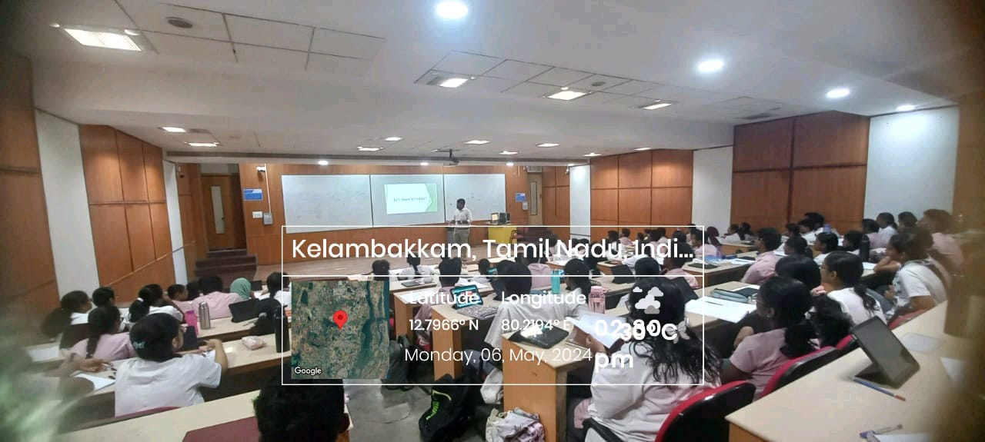

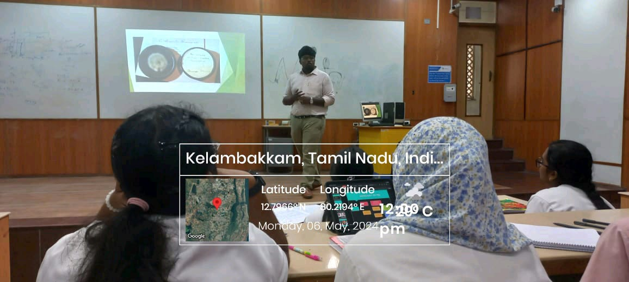

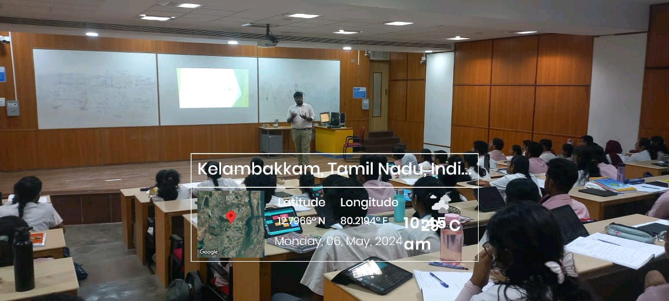

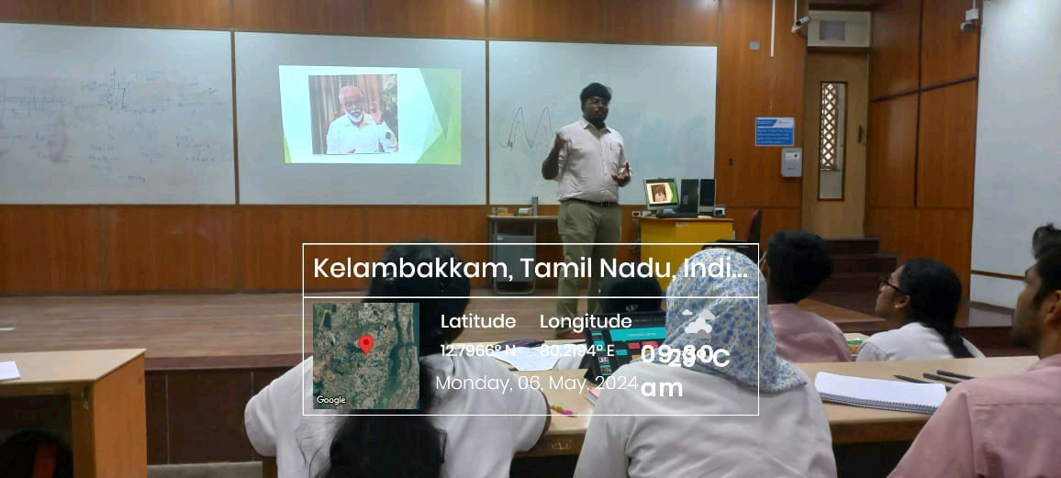

FEEDBACK ANALYSIS:

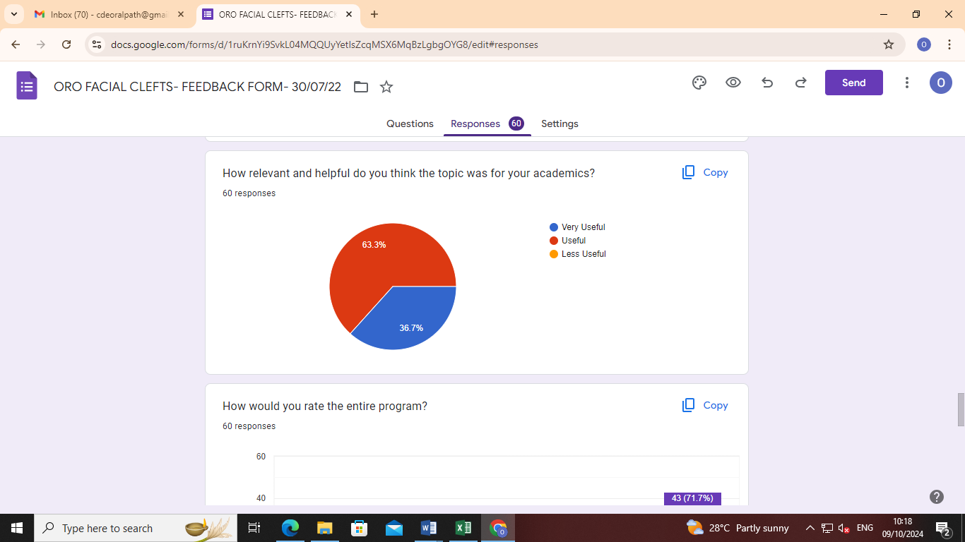

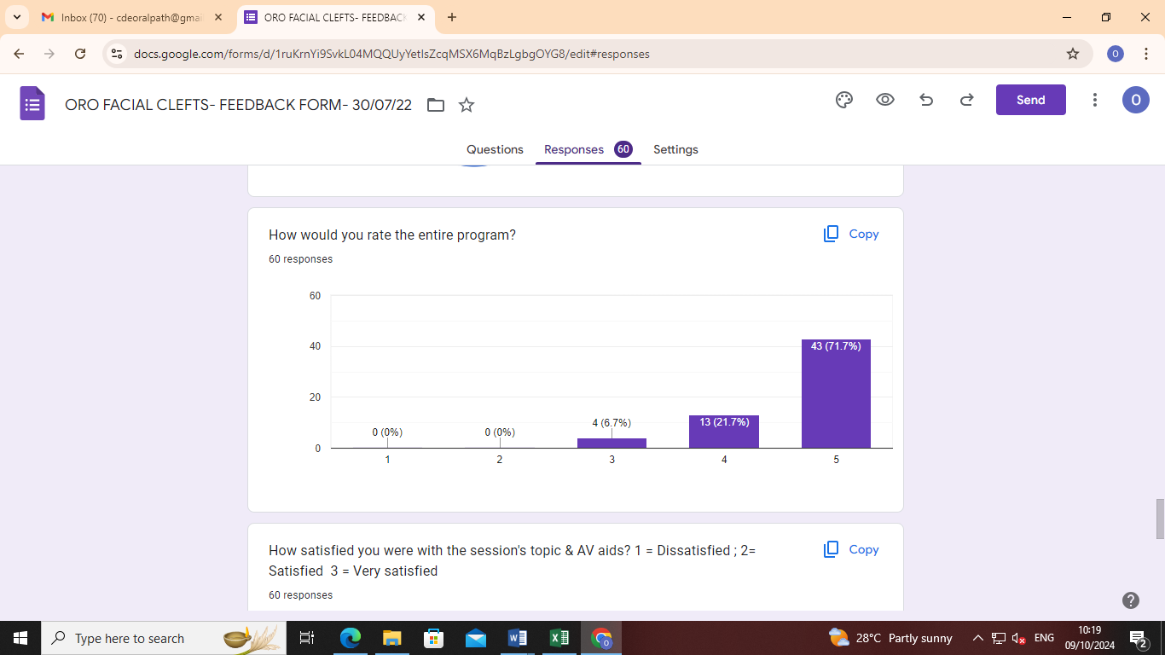

GUEST SPEAKER CERTIFICATE:

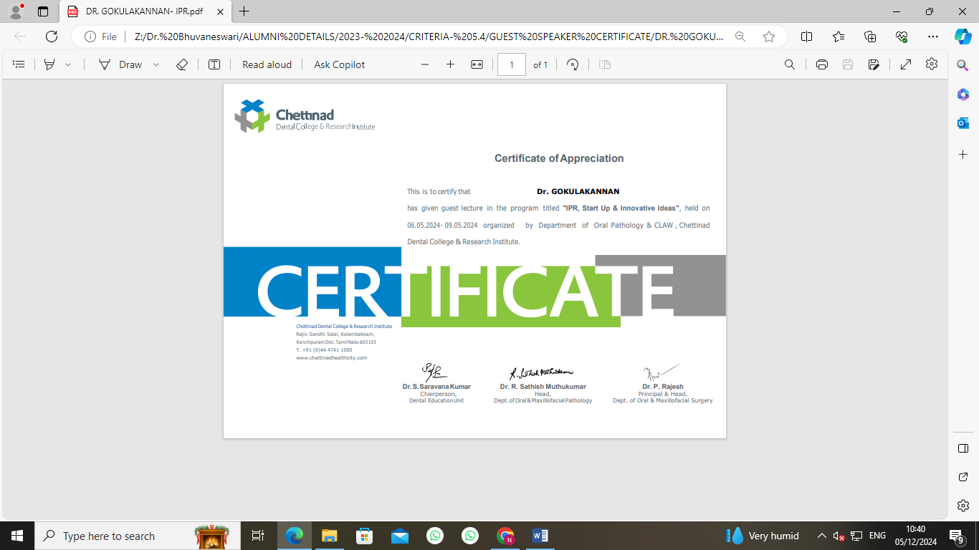

CIRCULAR

CLAW/2024/005 DATE: 09.05.2024

This is to inform that on behalf of CLAW and Department of Oral Pathology and Microbiology, along with Institutional Innovation Council are organizing a lecture on ‘NATIONAL TECHNOLOGY DAY 2024” on the topic of “Advanced Technologies in Dentistry”, on May 11th 2024 from 10.30 am- 12.00 pm. Kindly all CLAW members join the event, make it successful and benefitted.

Date: 11.05.2024

Time: 10.30 am- 12.00 pm

Zoom Link: https://us06web.zoom.us/j/87133532831?pwd=yMfUXqy5doxNlTtujHVmU8F3BdJVeP.1

Meeting Code: 871 3353 2831

Password: 028255

Regards,

The President
CLAW

Copy To
Hon’ble Secretary- For Information
Principal
All Committee Members
Office File

REPORT OF THE PROGRAM:

Date: 11/05/2024
Time: 10.30 am-m12.00 pm
Venue: E- Block Lecture Hall- 14
Zoom link: https://us06web.zoom.us/j/87133532831?pwd=yMfUXqy5doxNlTtujHVmU8F3BdJVeP.1
No of Participants: 106
BROCHURE:

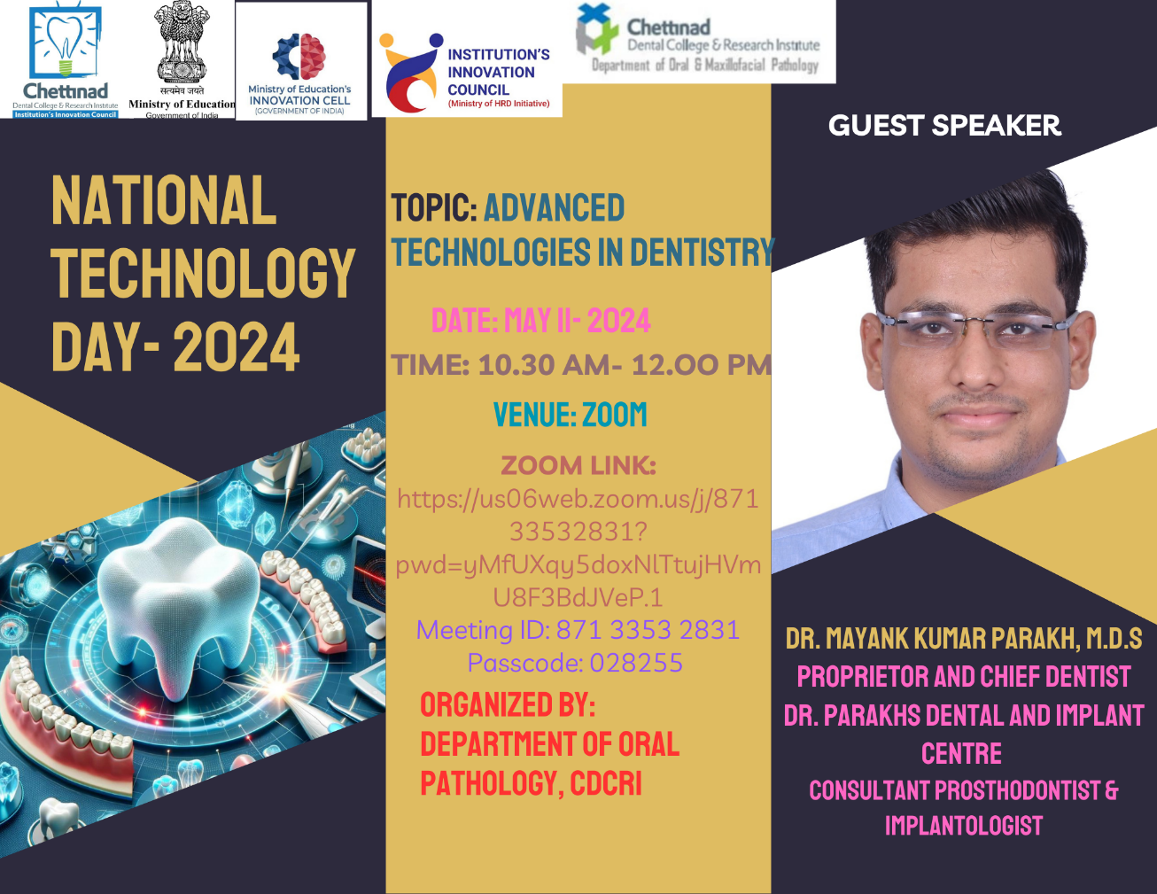
SESSION DETAILS
Title of session/ program | NATIONAL TECHNOLOGY DAY 2024- ADVANCED TECHNIQUES IN DENTISTRY
Date : | 11.05.2024
Time | From: 10 AM | To: 1 PM
Duration of the activity (in minutes) | 3 HOURS
Activity category | Commemorative Day Celebration
Theme of activity (Select one) | Technology In Dentistry
Mode of delivery | Online & Offline
EXPERT / SPEAKER DETAILS
Name of Speaker | Dr. Mayank Kumar Parakh
Designation | Proprietor and chief dentist Dr. Parakhs Dental and Implant Centre  Consultant Dr. Deepak Victors Dental Clinic, Ambrose Dental Clinic and VV Dental Hospital
Organization | Dr. Parakhs Dental and Implant Centre
Brief about Expert/Speaker:  (max 100 words) | Dr. Mayank is Star Alumni of CDCRI, who had won BP Rajan Gold medal from TN Dr MGR Medical University in his undergraduate program, Manjaya Shetty Award from Nitte University and Sharadha Rajeev Shetty award Nitte University after his post-graduation during his fellowships. He is also part of world record union for highest patients screened for cancer in a day (Project Vaipu). He has done Advanced certification in Oral Implantology- Nitte University. His field of interests are Prosthodontics, implantology, and oral cancer
OUTCOME OF ACTIVITY
Objective: (as bullet points – max 50 words) | - To attain knowledge on – advanced techniques in day to day practice  - To know about the recent advances in the field of dentistry and its various specialities.
Outcomes: (as bullet points – max 50 words) | - Students and faculties gained knowledge on various techniques of recent advances from oral examination, impression making, cast duplication, face analysis, restorative techniques and recent impression materials.  - Students and faculties gained knowledge on what are the difficulties in day to day practice that can ease through technologies and also what are the areas still lagging to introduce technologies.
Key highlights: (as bullet points – max 50 words) | Dr. Mayank started the program by 10.15 am with an introductory note from Dr. Sathish Muthukumar. His presentation covered almost all recent techniques In various specialities of dentistry starting from oral examination, impression making, cast duplication, face analysis, restorative techniques and recent impression materials. The session was very useful and learning.
PARTICIPANTS DETAILS
No. of Student Participants | 100
No. of Faculty Participants | 6
No. of External Participants (If any) | 0
Expenditure amount (if any) | Rs. 500

ATTENDANCE SHEET:

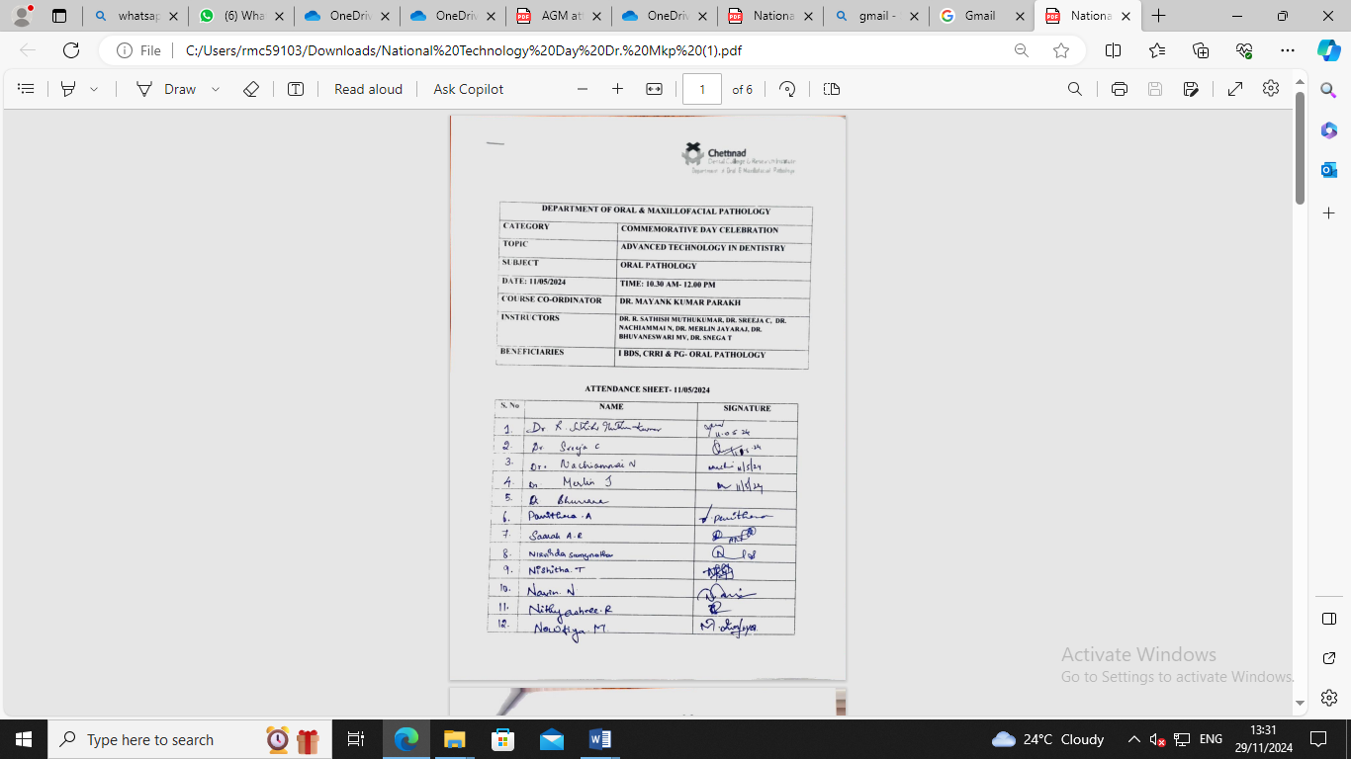
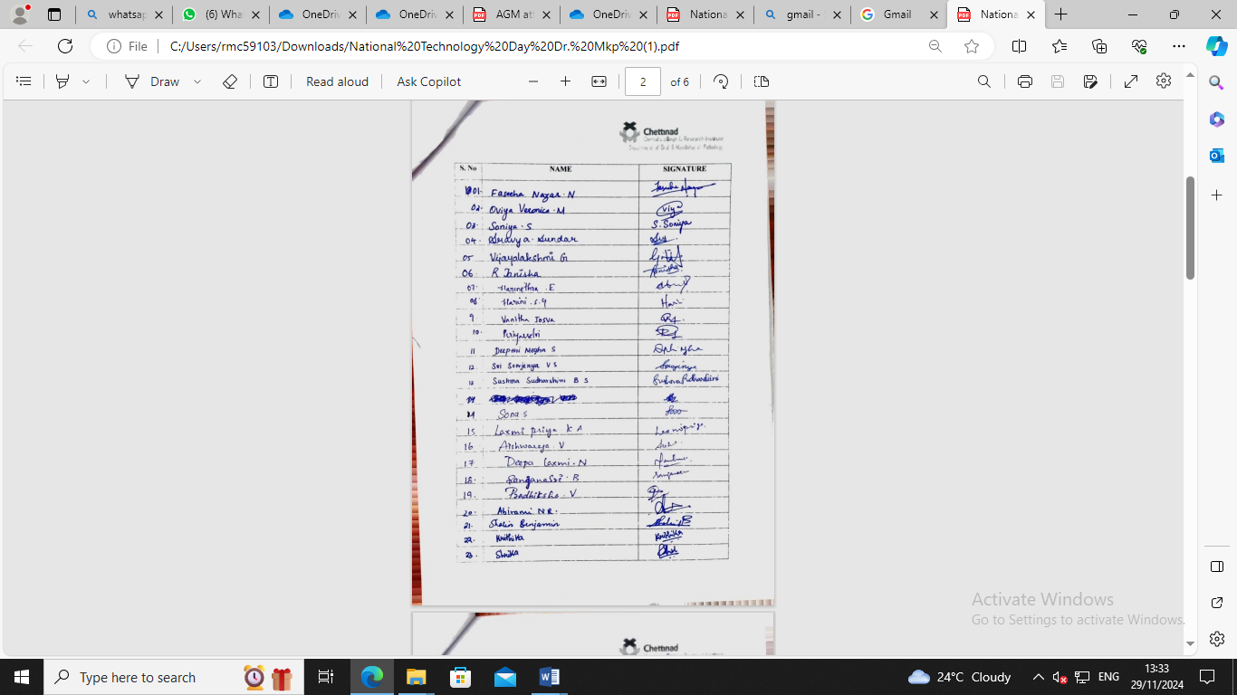

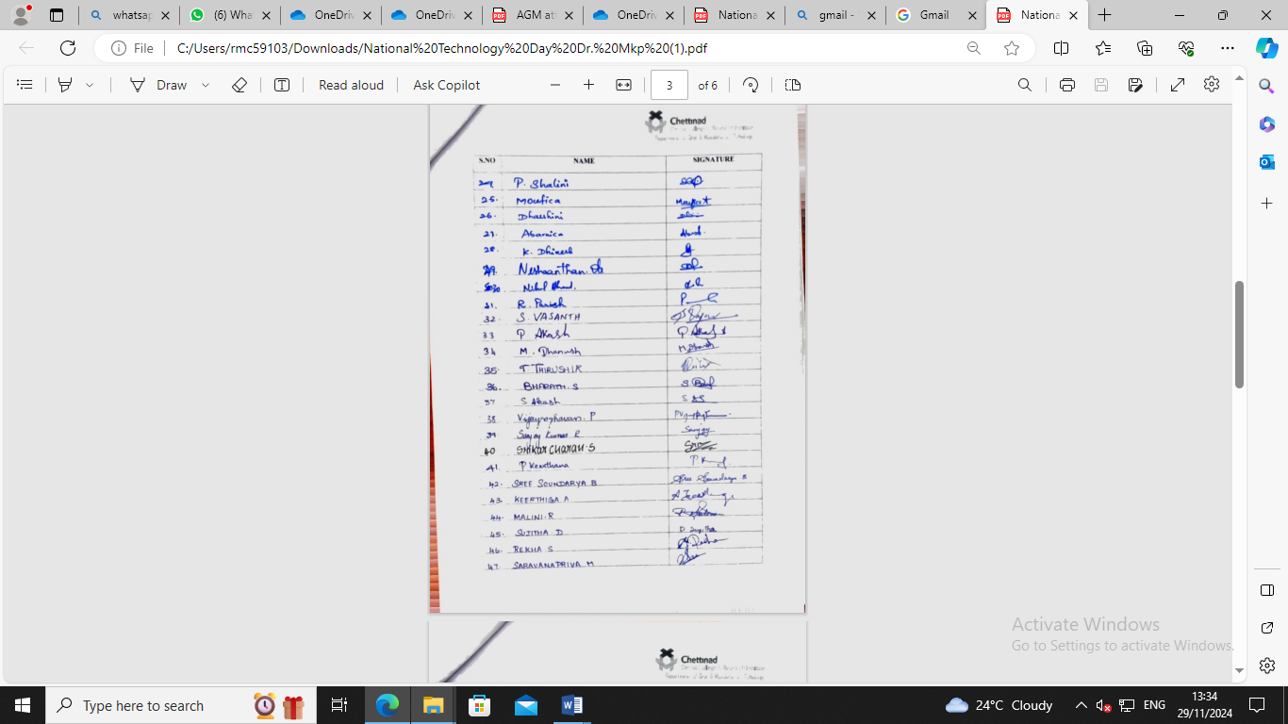
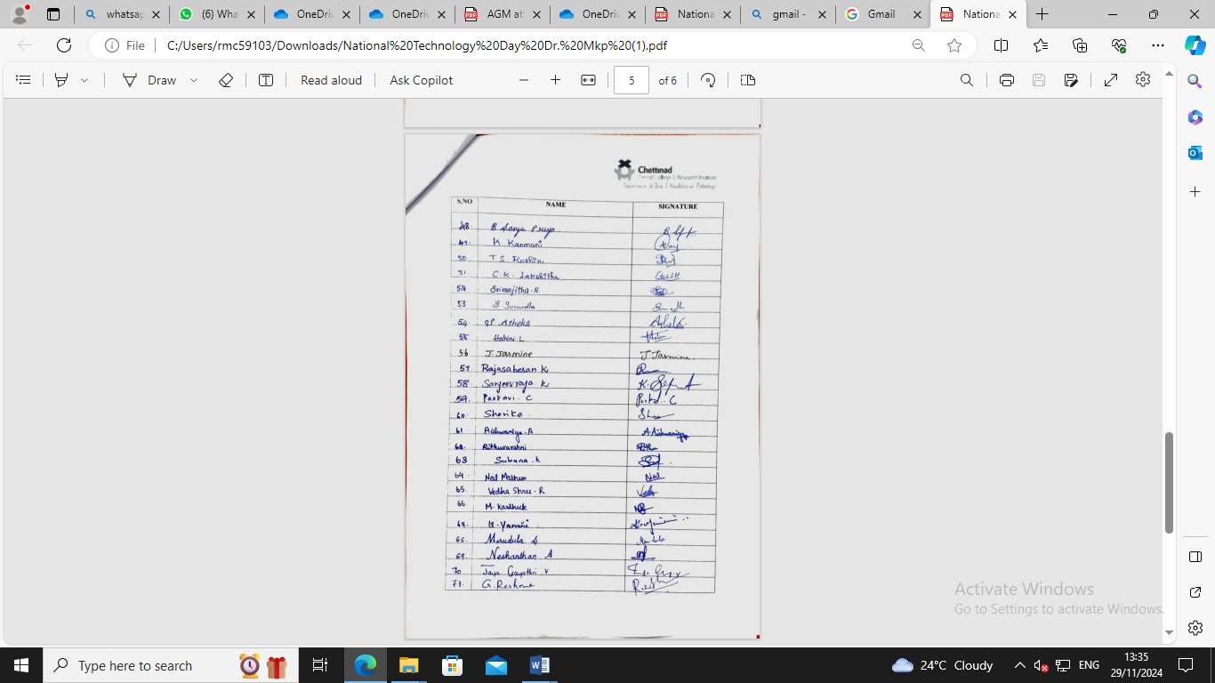

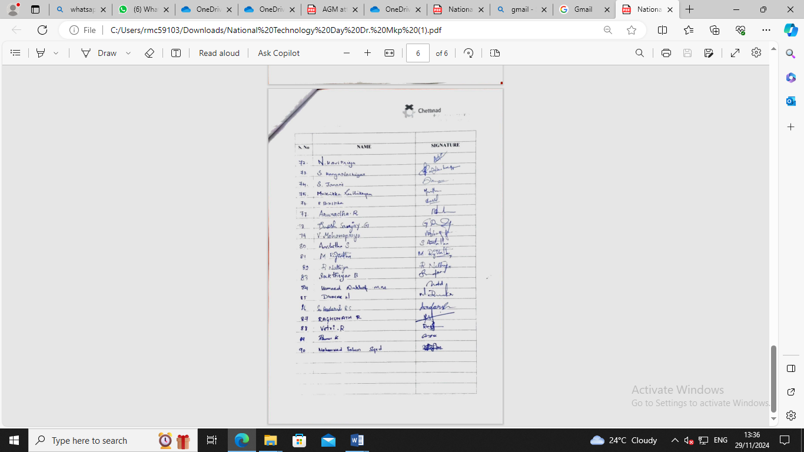

PROGRAM CONSTRAINTS:
None

ACKNOWLEDGEMENTS:

- The Department of Oral Pathology extends its thanks to management and administration for their support rendered.
- Sincere thanks to Dr.Mayank Kumar Parakh for guiding and supporting the students on this particular topic.
- Special thanks to Dr. Bhuvaneshwari for organizing this program

PROGRAM PHOTOGRAPHS:

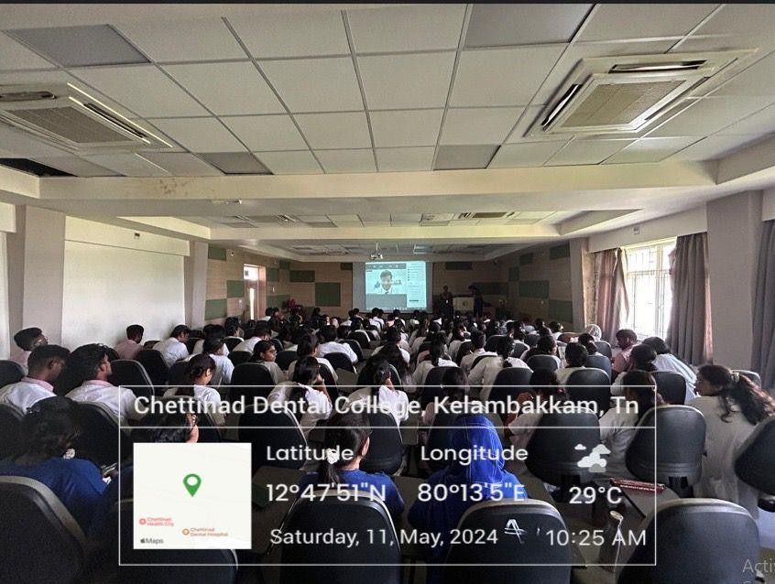

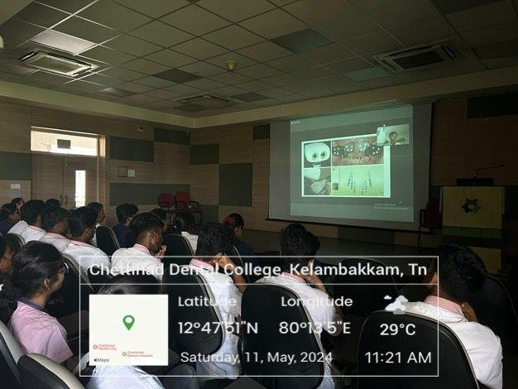

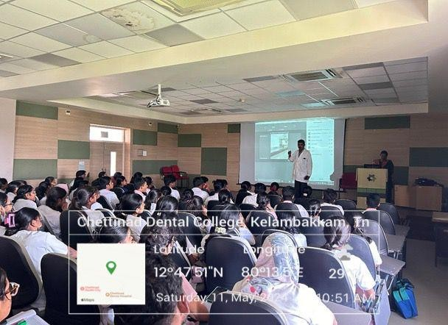

FEEDBACK ANALYSIS:

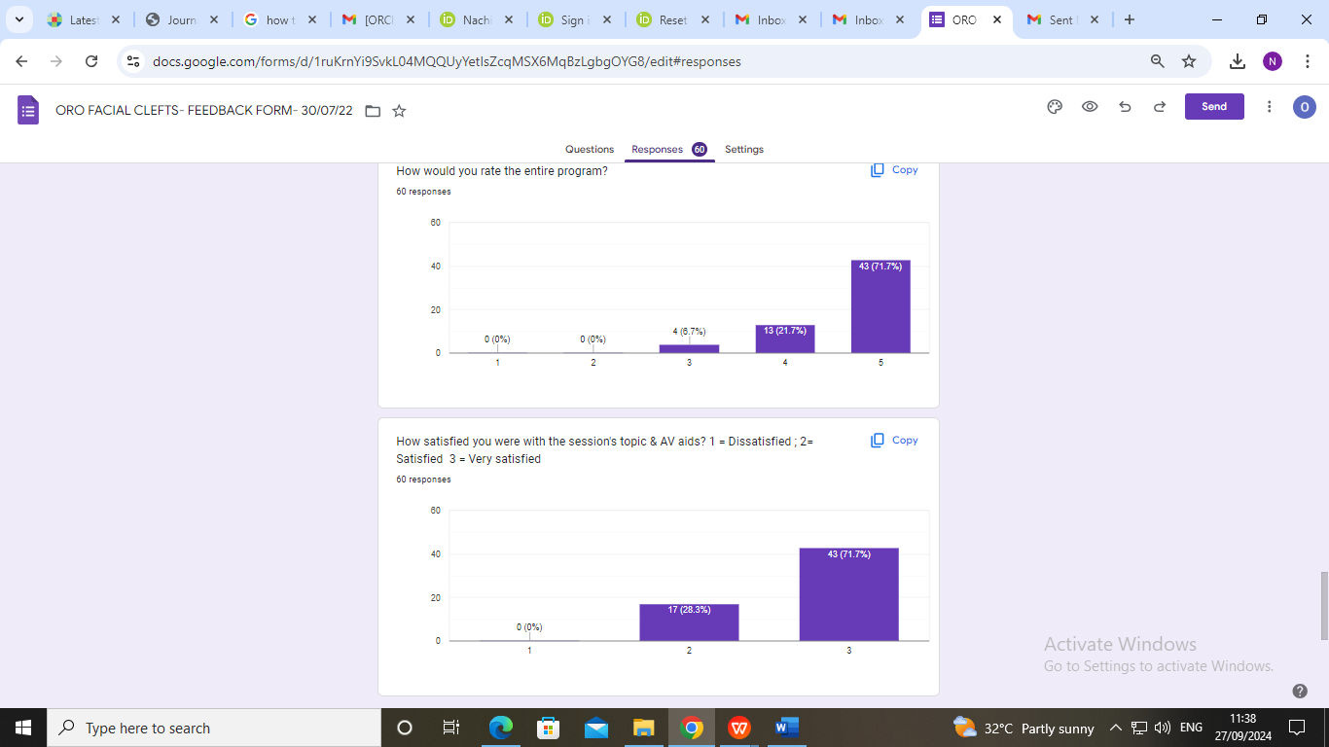

GUEST SPEAKER CERTIFICATE:

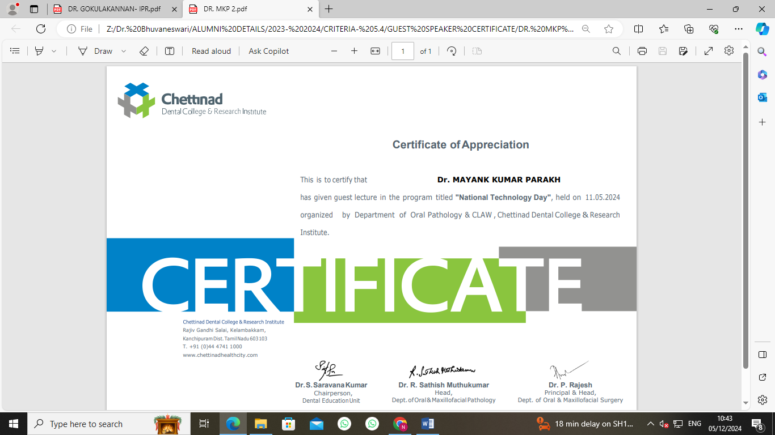

CIRCULAR

CLAW/2024/006 DATE: 14.05.2024

This is to inform that on behalf of CLAW and Department of Oral Pathology and Institutional Innovation Council, CDCRI organizing Lecture and an Interactive session on “Innovation & Design thinking” by Dr. Gokulakannan on 06.06.2024- 09.06.2024, from 10.30 am- 12.00 pm.

Date: 06.05.2024- 09.05.2024

Time: 9.00 am- 3.30 pm

Regards,

The President
CLAW

Copy To
Hon’ble Secretary- For Information
Principal
All Committee Members
Office File

REPORT OF THE PROGRAM:

Date: 06.06.2024 & 09.06.2024
Time 09.00AM- 3.30 PM
Venue: Academic Block- Lecture Hall
No of Participants: 283

BROCHURE:

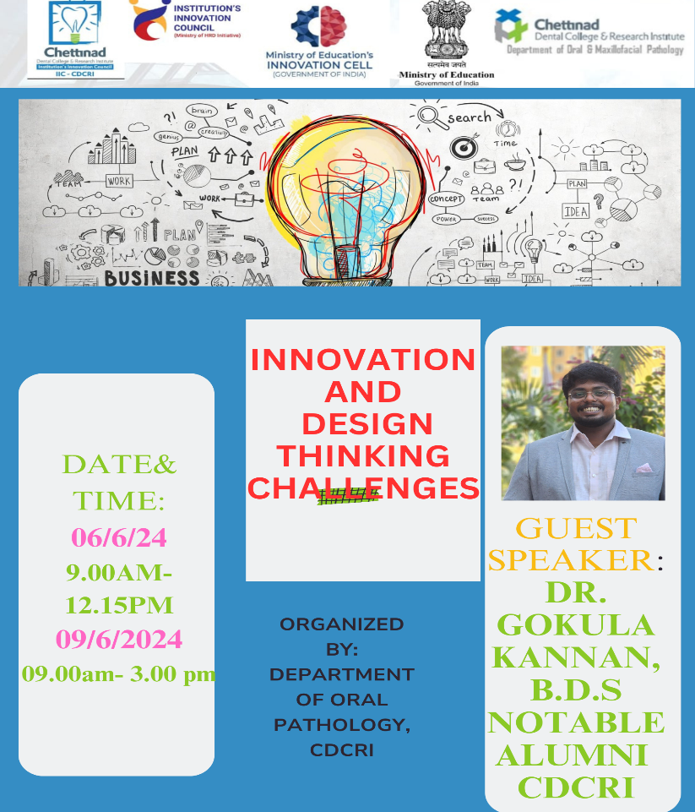

ACTIVITY REPORT- INSTITUTIONAL INNOVATION COUNCIL
IIC- CHETTINAD DENTAL COLLEGE & RESEARCH INSTITUTE
SESSION DETAILS
Title of session/ program | WORKSHOP ON INNOVATION AND DESIGN THINKING
Date : | 06.06.2024 | 09.06.2024
Time | From: 09.00am To: 12.15 PM | From: 9.00 am To: 03.00 PM
Duration of the activity (in minutes) | 9 HOURS
Activity category | Self -Driven activity
Theme of activity (Select one) | What is Innovation, What are innovative ideas and How to design the innovative ideas?
Mode of delivery | Offline
EXPERT / SPEAKER DETAILS
Name of Speaker | Dr. Gokulakannan BDS.,
Designation | Clinical Practitioner
Organization | Chettinad Hospital & Research Institute,
Brief about Expert/Speaker:  (max 100 words) | Dr. Gokulakannan is a notable alumnus of Chettinad dental college and research institute who was known for his enthusiastic and energetic passion in academics from his first year undergraduate period. He had one national and two international publications, two copyrights and one patent which are his notable records and achievements as an undergraduate student. He has presented four posters and won two best poster awards in MIDAS event as an undergraduate which will be conducted every year.
OUTCOME OF ACTIVITY
Objective: (as bullet points – max 50 words) | - To make student understand what is innovation  - To make them understand how to think and create Innovative Ideas  - To educate them about the designing process  - To make them understand how to think and get ideas on innovation
Outcomes: (as bullet points – max 50 words) | The speaker gave an insight to institutional innovation council and its function in an institution. He also narrated his journey as an undergraduate and how his interest in research make him to invent things in micromotor and apply for patent by guidance from faculties. He discussed what is innovation and how to think creatively to get an idea. He also explained well in brief how to think creatively to get innovative ideas, how to design the ideas. There are different form of innovative ideas and he explained how these ideas should be designed in a proper form for explaining the ideas to fellow colleagues, researcher / innovator to get it approved and for further processing.
Key highlights: (as bullet points – max 50 words) | - Students actively listened and asked questions about innovations  - Most of the students presented their innovative ideas, patent ideas and few start up applications at the end of the session
PARTICIPANTS DETAILS
No. of Student Participants | 275
No. of Faculty Participants | 6
No. of External Participants (If any) | 0
Expenditure amount (if any) | Rs. 1000

ATTENDANCE SHEET:

Attendance List of Faculty Participants
S.No | Name | Designation | Department
 | DR SATHISH MUTHUKUMAR R | HOD & PROFESSOR | ORAL PATHOLOGY
 | DR SREEJA | PROFESSOR | ORAL PATHOLOGY
 | DR NACHIAMMAI | READER | ORAL PATHOLOGY
 | DR MERLIN | READER | ORAL PATHOLOGY
 | DR BHUVANESWARI | SENIOR LECTURER | ORAL PATHOLOGY
 | DR SNEGA | SENIOR LECTURER | ORAL PATHOLOGY

Attendance List of Student Participants
S.NO | NAME | STUDENT | INSTITUTION
1 | AASHITHAA S | I BDS | CDCRI
2 | ABARNICA S | I BDS | CDCRI
3 | ABIRAMI N R | I BDS | CDCRI
4 | AISHWARYA A | I BDS | CDCRI
5 | AISHWARYA VENKATESH | I BDS | CDCRI
6 | AKASH P | I BDS | CDCRI
7 | AKASH S | I BDS | CDCRI
8 | ALGREET A | I BDS | CDCRI
9 | ANURADHA R | I BDS | CDCRI
10 | ARUNACHALAM A | I BDS | CDCRI
11 | ASHEKA S | I BDS | CDCRI
12 | BHARANIKA M | I BDS | CDCRI
13 | BHARATH S | I BDS | CDCRI
14 | DEEKSHITHA S | I BDS | CDCRI
15 | DEEPALAXMI M | I BDS | CDCRI
16 | DEEPTHI MEGHA S | I BDS | CDCRI
17 | DHANUSH M | I BDS | CDCRI
18 | DHARSHINI D | I BDS | CDCRI
19 | DHINESH K | I BDS | CDCRI
20 | DINESH SANJAY G | I BDS | CDCRI
21 | DIVAKAR | I BDS | CDCRI
22 | FASEEHA NAZAR N | I BDS | CDCRI
23 | HAHINI L | I BDS | CDCRI
24 | HAMEED NAHHAF M | I BDS | CDCRI
25 | HARI SNEHA S | I BDS | CDCRI
26 | HARI NETHRA E | I BDS | CDCRI
27 | HARINI S G | I BDS | CDCRI
28 | JANANI S | I BDS | CDCRI
29 | JASMINE J | I BDS | CDCRI
30 | JAYA GAYATHRI V | I BDS | CDCRI
31 | JENEFA E H | I BDS | CDCRI
32 | KANMANI.K | I BDS | CDCRI
33 | KARTHICK M | I BDS | CDCRI
34 | KAVIPRIYA N | I BDS | CDCRI
35 | KEERTHANA P | I BDS | CDCRI
36 | KEERTHIGAA A | I BDS | CDCRI
37 | KRITHIKA P | I BDS | CDCRI
38 | LAKSHITHA C K | I BDS | CDCRI
39 | LAXMI PRIYA | I BDS | CDCRI
40 | MALINI R | I BDS | CDCRI
41 | MANASA S | I BDS | CDCRI
42 | MIRDULA S | I BDS | CDCRI
43 | MOHAMMED FAHIM SYED | I BDS | CDCRI
44 | MOHANA PRIYA | I BDS | CDCRI
45 | MOUFICA | I BDS | CDCRI
46 | MRITHIKA KARTHIKEYAN | I BDS | CDCRI
47 | NATHIYA | I BDS | CDCRI
48 | NEIL MATHUR | I BDS | CDCRI
49 | NESHAANDHAN | I BDS | CDCRI
50 | NIHAL AHMED | I BDS | CDCRI
51 | NISHITHA U K | I BDS | CDCRI
52 | OVIYA VERONIKA | I BDS | CDCRI
53 | PARISH R | I BDS | CDCRI
54 | PARKAVI C | I BDS | CDCRI
55 | PERIYAR SELVI | I BDS | CDCRI
56 | PRADHISHA V | I BDS | CDCRI
57 | RAGUNATH R | I BDS | CDCRI
58 | RAJA SABESAN K | I BDS | CDCRI
59 | RAMU K | I BDS | CDCRI
60 | RANGANACHIYAR | I BDS | CDCRI
61 | REKA S | I BDS | CDCRI
62 | RESHMA G | I BDS | CDCRI
63 | RIGVEDHA M | I BDS | CDCRI
64 | RITHISHA | I BDS | CDCRI
65 | RITHU VARSHINI | I BDS | CDCRI
66 | ROSHINI T S | I BDS | CDCRI
67 | SAI AADARSH | I BDS | CDCRI
68 | SAKTHI YAN B | I BDS | CDCRI
69 | SANGOJU SHRIKA | I BDS | CDCRI
70 | SANJANASRI | I BDS | CDCRI
71 | SANJAY KUMAR | I BDS | CDCRI
72 | SANJEEVRAJA | I BDS | CDCRI
73 | SANJU PRIYA | I BDS | CDCRI
74 | SARAVANA PRIYA | I BDS | CDCRI
75 | SHALIN BENJAMIN | I BDS | CDCRI
76 | SHALINI P | I BDS | CDCRI
77 | SHARIKA | I BDS | CDCRI
78 | SHRISTIKA | I BDS | CDCRI
79 | SONA S | I BDS | CDCRI
80 | SONIYA S | I BDS | CDCRI
81 | SHRAVYA SUNDAR | I BDS | CDCRI
82 | SREE SOUNDHARYA | I BDS | CDCRI
83 | SRI SOWJANYA | I BDS | CDCRI
84 | SRIKAR CHARAN S | I BDS | CDCRI
85 | SRI RANJITHA R | I BDS | CDCRI
86 | SUBANA K | I BDS | CDCRI
87 | SUJITHA D | I BDS | CDCRI
88 | SUSHMA SUDHARSHINI B S | I BDS | CDCRI
89 | SUWEDHA | I BDS | CDCRI
90 | THANISHA R | I BDS | CDCRI
91 | THIRUSHIK T | I BDS | CDCRI
92 | VAISHNAVI S | I BDS | CDCRI
93 | VANITHA JOSVA R | I BDS | CDCRI
94 | VASANTH S | I BDS | CDCRI
95 | VEDHASHREE R | I BDS | CDCRI
96 | VETRI R | I BDS | CDCRI
97 | VIJAYALAKSHMI G | I BDS | CDCRI
98 | VIJAYRAGHAVAN P | I BDS | CDCRI
99 | VIYAS S | I BDS | CDCRI
100 | YAMINI K | I BDS | CDCRI
101 | ABITHA G | II BDS | CDCRI
102 | ADONCIA DEBORAH A JOSE | II BDS | CDCRI
103 | AISHVARYA R | II BDS | CDCRI
104 | AISHVARYA KAMAKSHI V | II BDS | CDCRI
105 | AISHWARYA R | II BDS | CDCRI
106 | AJITHA R | II BDS | CDCRI
107 | AMIRTHA S | II BDS | CDCRI
108 | ANISHA R | II BDS | CDCRI
109 | ANUSHYA A | II BDS | CDCRI
110 | ARJUN B | II BDS | CDCRI
111 | ARULDHAVAN K | II BDS | CDCRI
112 | AYSHA NASREEN A | II BDS | CDCRI
113 | BADHRINARAYANAN B K | II BDS | CDCRI
114 | BOOMIKA R | II BDS | CDCRI
115 | DEEPIKA D | II BDS | CDCRI
116 | DHANUSH R | II BDS | CDCRI
117 | HARITHA R | II BDS | CDCRI
118 | HEMALATHA P K | II BDS | CDCRI
119 | HENINNA V | II BDS | CDCRI
120 | JAYAKRISHNAN M | II BDS | CDCRI
121 | JAYASHRI P C | II BDS | CDCRI
122 | JOEL VASANTH | II BDS | CDCRI
123 | KALAI SELVI V | II BDS | CDCRI
124 | KALPANA S | II BDS | CDCRI
125 | KAVIN V | II BDS | CDCRI
126 | KAVIN KISHORE S | II BDS | CDCRI
127 | KAVIYA PRIYA B | II BDS | CDCRI
128 | KRITHIKA V | II BDS | CDCRI
129 | LAVANYA S | II BDS | CDCRI
130 | LITHIKA M | II BDS | CDCRI
131 | MALARKODI G S | II BDS | CDCRI
132 | MANASI D | II BDS | CDCRI
133 | MANSII SAGAR G | II BDS | CDCRI
134 | MARINA M | II BDS | CDCRI
135 | MAYUKHA S | II BDS | CDCRI
136 | MOHANA DHARSHINI R | II BDS | CDCRI
137 | MOHANAMBAL M | II BDS | CDCRI
138 | MOTHESH KUMAR M | II BDS | CDCRI
139 | NARTHANA S | II BDS | CDCRI
140 | NAVAMITHRA S | II BDS | CDCRI
141 | NAVEENA L | II BDS | CDCRI
142 | NAZLA FATHIMA I | II BDS | CDCRI
143 | NITHIYA K S | II BDS | CDCRI
144 | NITHYASHREE J S | II BDS | CDCRI
145 | PADMA PRIYA T K | II BDS | CDCRI
146 | PADMAJA B N | II BDS | CDCRI
147 | POOJA S | II BDS | CDCRI
148 | PRAGATHI K | II BDS | CDCRI
149 | PURUJITH SREERAM R U | II BDS | CDCRI
150 | RAJALAKSHMI R | II BDS | CDCRI
151 | RAJASREE S | II BDS | CDCRI
152 | RENIN MARIA A | II BDS | CDCRI
153 | RESHMIKA A | II BDS | CDCRI
154 | RIYAZUDDIN T N | II BDS | CDCRI
155 | SAKAYA VIVEKRAJ P | II BDS | CDCRI
156 | SAKTHI SONA S S | II BDS | CDCRI
157 | SAKTHISREE A | II BDS | CDCRI
158 | SANDHIYA C | II BDS | CDCRI
159 | SANOFAR S | II BDS | CDCRI
160 | SANTHISH N | II BDS | CDCRI
161 | SARAVANA PRIYESH S | II BDS | CDCRI
162 | SARAVANA PRIYA E | II BDS | CDCRI
163 | SARGUNA PRIYAN Y | II BDS | CDCRI
164 | SARVESHWARAN S | II BDS | CDCRI
165 | SHAIRAM M | II BDS | CDCRI
166 | SHANYA NARASIMHAN | II BDS | CDCRI
167 | SHARUMATHI A | II BDS | CDCRI
168 | SHIRANJEEVEE R | II BDS | CDCRI
169 | SHIVANI K | II BDS | CDCRI
170 | SHREENITHI S | II BDS | CDCRI
171 | SHRIMUHI A M | II BDS | CDCRI
172 | SIERISHA S | II BDS | CDCRI
173 | SINDHU R | II BDS | CDCRI
174 | SRI SELVA LAKSHMI M | II BDS | CDCRI
175 | SRUTHI S | II BDS | CDCRI
176 | SUBHASH CHANDAR | II BDS | CDCRI
177 | SWASTHIGA A | II BDS | CDCRI
178 | SWETHA T | II BDS | CDCRI
179 | SYED ALI FATHIMA S | II BDS | CDCRI
180 | VAISHALI S | II BDS | CDCRI
181 | VIDYA V | II BDS | CDCRI
182 | VIGKNESH S | II BDS | CDCRI
183 | VIJAI PRAKASH G R | II BDS | CDCRI
184 | YAMINI A | II BDS | CDCRI
185 | ZUBEIDA NASREEN S H | II BDS | CDCRI
186 | AARATHI S | III BDS | CDCRI
187 | AISHWARYA G | III BDS | CDCRI
188 | AJITHKUMAR M | III BDS | CDCRI
189 | AKSHAY KUMAR R | III BDS | CDCRI
190 | AKSHAYA R E | III BDS | CDCRI
191 | ANTO LANCILA T | III BDS | CDCRI
192 | APOORVA B | III BDS | CDCRI
193 | ARUTCO M | III BDS | CDCRI
194 | ASFIYA SULTHANA B H | III BDS | CDCRI
195 | AVIREDDY DIVYA RAGA NIHA | III BDS | CDCRI
196 | BALAVIGNESH | III BDS | CDCRI
197 | BAVADHARINI S | III BDS | CDCRI
198 | BEN ISRAEL D | III BDS | CDCRI
199 | BHUVANASRI J M | III BDS | CDCRI
200 | CHARU VIKRAM R | III BDS | CDCRI
201 | DEIVANAI C | III BDS | CDCRI
202 | DHARANIDHARAN T | III BDS | CDCRI
203 | DORTHY DEBORAH EVANGE | III BDS | CDCRI
204 | FAIZAL AKTHAR A | III BDS | CDCRI
205 | GOWSALYA M | III BDS | CDCRI
206 | JANANI R | III BDS | CDCRI
207 | JASMINE SWITHIRA I | III BDS | CDCRI
208 | JINU GIJO | III BDS | CDCRI
209 | JOYCE BLESSINA GRACE B | III BDS | CDCRI
210 | KAILASH S | III BDS | CDCRI
211 | KAMALI G | III BDS | CDCRI
212 | KARTHIGA A | III BDS | CDCRI
213 | KAVIN KISHORE J M | III BDS | CDCRI
214 | KAVYAPRIYA S | III BDS | CDCRI
215 | KEERTHANA S | III BDS | CDCRI
216 | KEERTHANA SRI S | III BDS | CDCRI
217 | LAKSHITAA J | III BDS | CDCRI
218 | LAKSHMIPRIYA S | III BDS | CDCRI
219 | LASHMI C S | III BDS | CDCRI
220 | LOGESH ARJUN N | III BDS | CDCRI
221 | MANGAI M A | III BDS | CDCRI
222 | MANISHA BHARATHI R | III BDS | CDCRI
223 | MEENAKSHI R | III BDS | CDCRI
224 | MIDHUNA N S | III BDS | CDCRI
225 | MOHAMMED AFRIDH K | III BDS | CDCRI
226 | MOHANAPRIYA T N | III BDS | CDCRI
227 | MRIDULA K | III BDS | CDCRI
228 | NABILA A | III BDS | CDCRI
229 | NALINA S | III BDS | CDCRI
230 | NANDHINI S | III BDS | CDCRI
231 | NAVETH K | III BDS | CDCRI
232 | NEETHA KRISH J | III BDS | CDCRI
233 | NITHESH M | III BDS | CDCRI
234 | NITHISH S | III BDS | CDCRI
235 | ORMILA DEVI M | III BDS | CDCRI
236 | PAVITHRA DEVI R | III BDS | CDCRI
237 | PONKEERTHANA S | III BDS | CDCRI
238 | PRAKALYA T I | III BDS | CDCRI
239 | PRIYA S | III BDS | CDCRI
240 | PRIYADHARSHINI D K | III BDS | CDCRI
241 | RAAJASHRI V | III BDS | CDCRI
242 | RIFA HANNIYA | III BDS | CDCRI
243 | RITHANYA A B | III BDS | CDCRI
244 | RIYA FATHIMA K | III BDS | CDCRI
245 | ROSHINI SOFIYA R | III BDS | CDCRI
246 | SAGAYA JENISHA F | III BDS | CDCRI
247 | SAMYUKTHA S | III BDS | CDCRI
248 | SARANYA R | III BDS | CDCRI
249 | SATHIYA S | III BDS | CDCRI
250 | SEYED HAGFIL MARAIKA S | III BDS | CDCRI
251 | SHAIK HAFSHA | III BDS | CDCRI
252 | SHALINI M | III BDS | CDCRI
253 | SHANMUGAM K | III BDS | CDCRI
254 | SHARANYA S B | III BDS | CDCRI
255 | SHARUN G | III BDS | CDCRI
256 | SHELMI R | III BDS | CDCRI
257 | SHREYAS | III BDS | CDCRI
258 | SHRIDEVI S L | III BDS | CDCRI
259 | SINEHA P | III BDS | CDCRI
260 | SIRANJEEVI R | III BDS | CDCRI
261 | SIVAKAMU K | III BDS | CDCRI
262 | SONIA A J | III BDS | CDCRI
263 | SOWBAGYA S | III BDS | CDCRI
264 | SRI HARINI U | III BDS | CDCRI
265 | SRIMATHI S | III BDS | CDCRI
266 | SRUTI S | III BDS | CDCRI
267 | SUBHIKSHA E | III BDS | CDCRI
268 | SUBHIKSHA S | III BDS | CDCRI
269 | SUDHARSAN N | III BDS | CDCRI
270 | SUKI KRISHNAKANTH K | III BDS | CDCRI
271 | SURIYA PRAKASAN M | III BDS | CDCRI
272 | SWATHY C | III BDS | CDCRI
273 | SWATHY SURESH KUMAR S | III BDS | CDCRI
274 | THARANI S | III BDS | CDCRI
275 | THARUN S | III BDS | CDCRI
276 | VAISHNAVI M | III BDS | CDCRI
277 | VARSHA RAJ M G | III BDS | CDCRI
278 | VETRIVEL K | III BDS | CDCRI
279 | VIDYAA V S | III BDS | CDCRI
280 | VISHALI K R | III BDS | CDCRI
281 | YAMINI S | III BDS | CDCRI
282 | YESWINI S | III BDS | CDCRI
283 | YOGESHWARI M | III BDS | CDCRI

GEOTAGGED PHOTOGRAPHS:

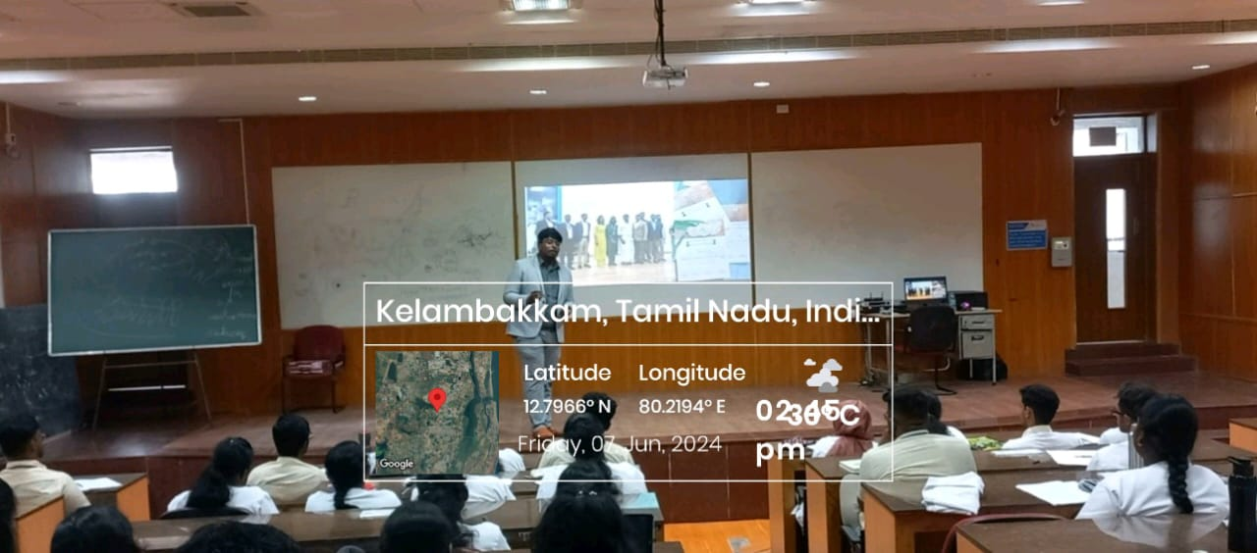

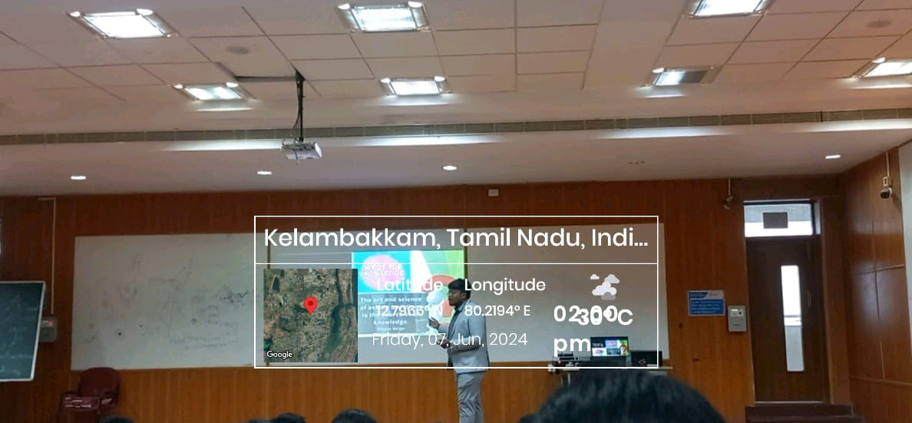

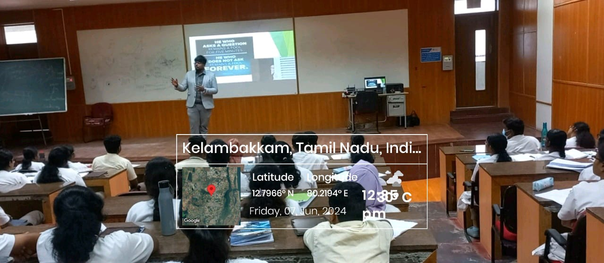

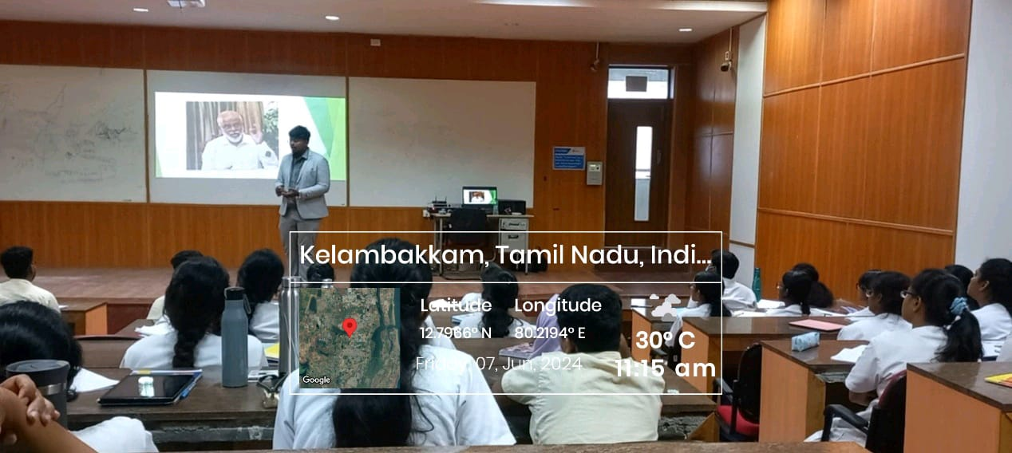

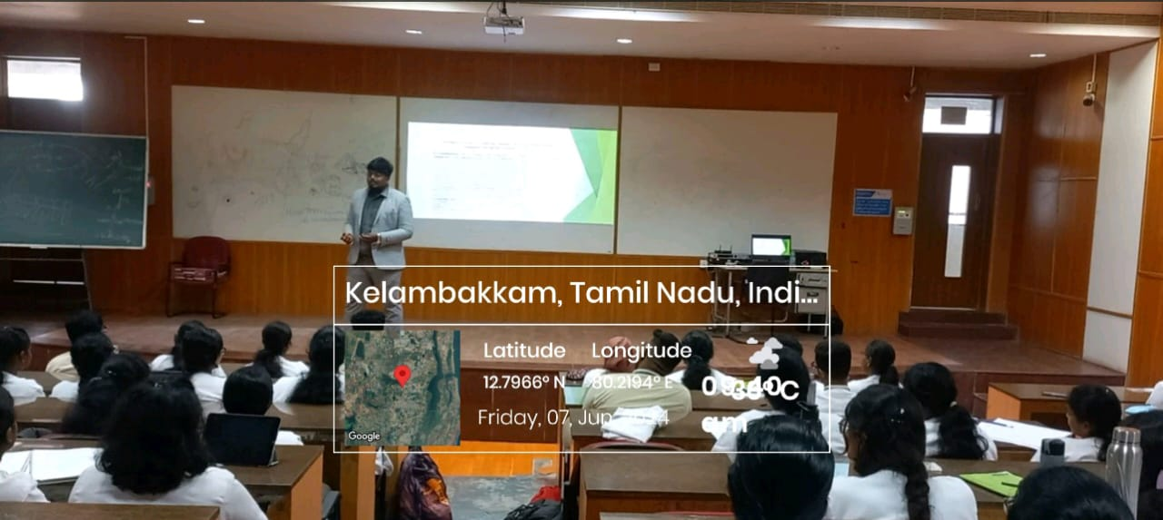

FEEDBACK ANALYSIS:

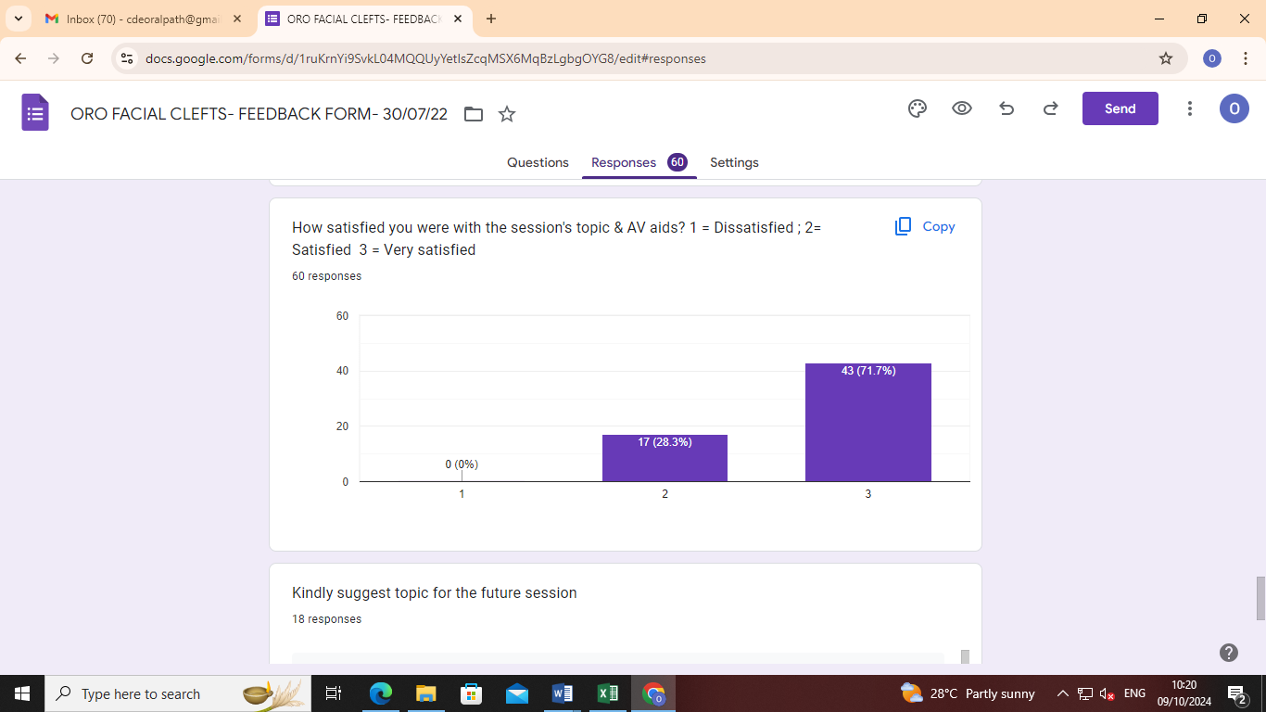

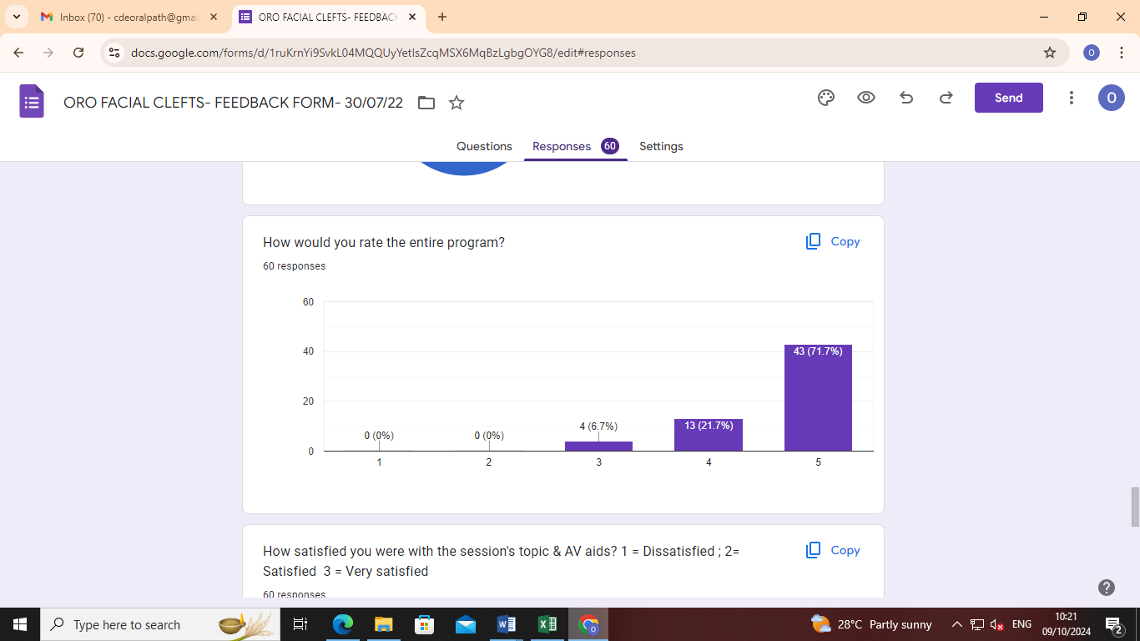

GUEST SPEAKER CERTIFICATE:

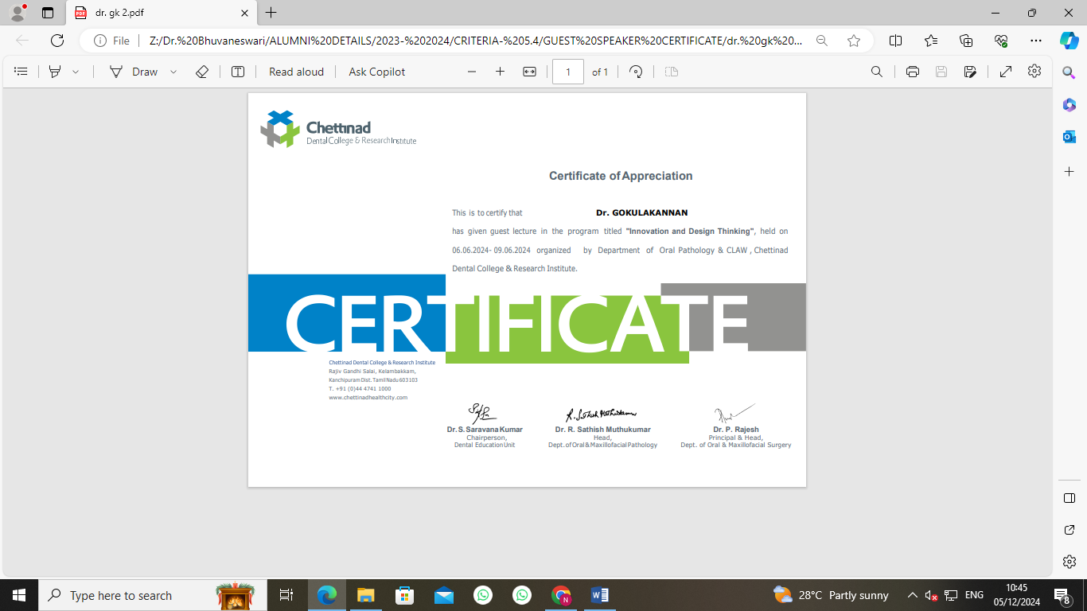

CIRCULAR

CLAW/2024/007 DATE: 17.06.2024

This is to inform that on behalf of CLAW and Department of Periodontics and Institutional Innovation Council, CDCRI organizing Lecture and an Interactive session on “Open Flap Debridement” by Dr. Ranjana and Dr. Sofiya Merlin Dawson on 21.06.2024, from 10.30 am- 12.00 pm.

Date: 21.06.2024

Time: 09.00 am- 02.00 pm

Regards,

The President
CLAW

Copy To
Hon’ble Secretary- For Information
Principal
All Committee Members
Office File

REPORT OF THE PROGRAM:

Date: 21/06/2024
Time: 09.00 am- 3.30 pm
Venue: Department of Periodontics
No of Participants: 116

BROCHURE:

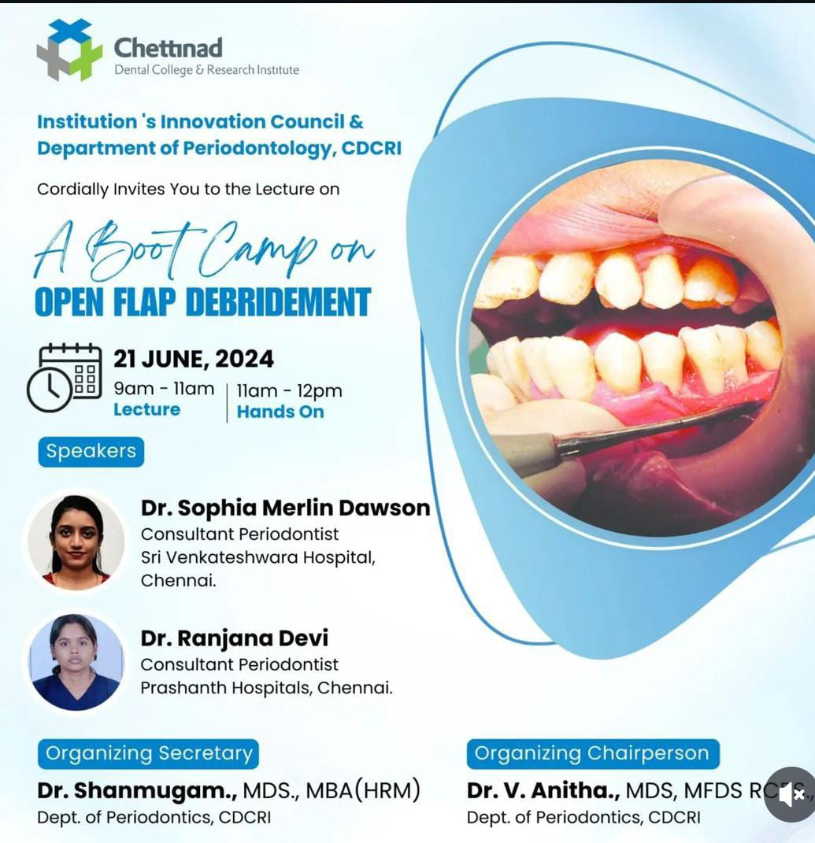

PROGRAM HIGHLIGHTS:

The event started by 9.30 am with total of 35 students including CRIs and post graduates of the college. Dr. Radhika gave an introductory note about the proud alumni- Dr. Sofiya and Dr. Ranjana. Dr. Sofiya and Dr. Ranjana gave lectures on the basics of flap, procedures for elevating the flap, and the clinical conditions when flap surgery is required. The lecture ended by 12.30 pm. From 1.30 – 3.00 pm all students had hands on workshop on flap surgical procedure. Both the guest speakers gave an excellent hands on techniques on model cast with surgical instruments and students understood effectively. The event ended by 3.15pm. Dr. Anitha presented the speakers with memento and certificates.

ATTENDANCE SHEET:

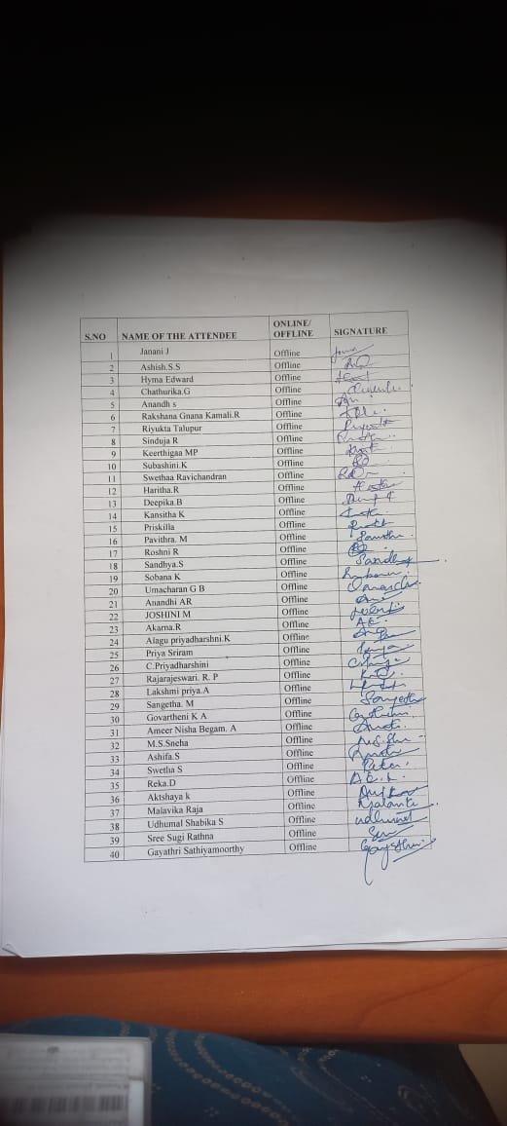
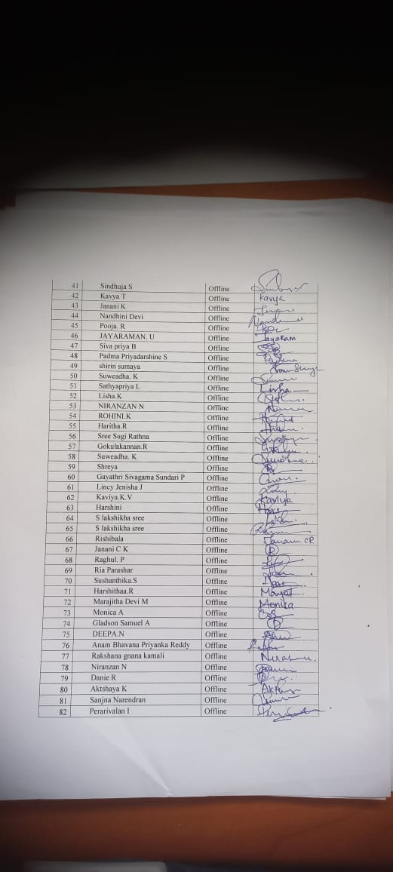

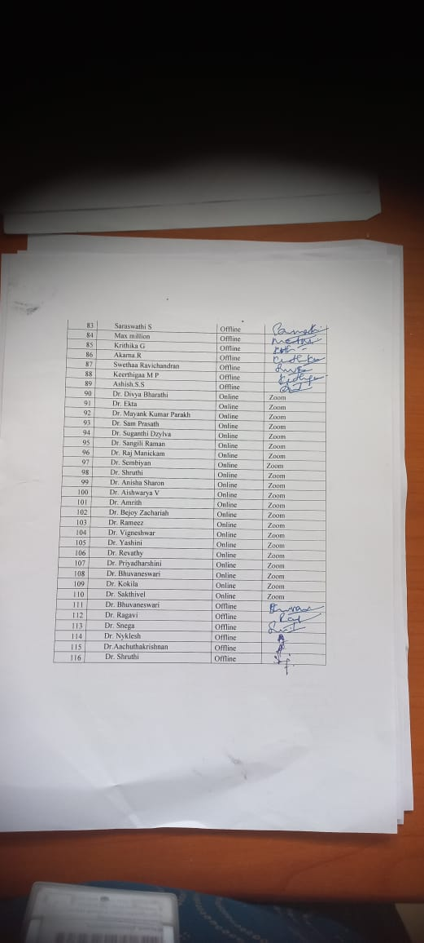

GEOTAGGED PHOTOGRAPHS:

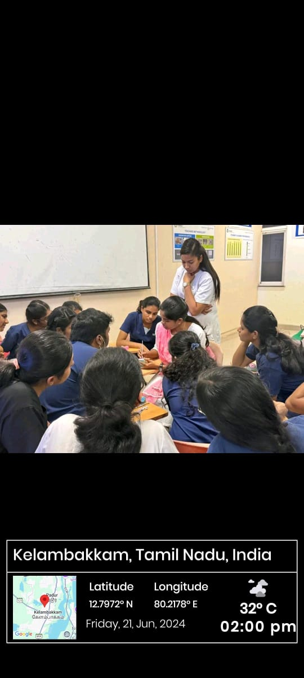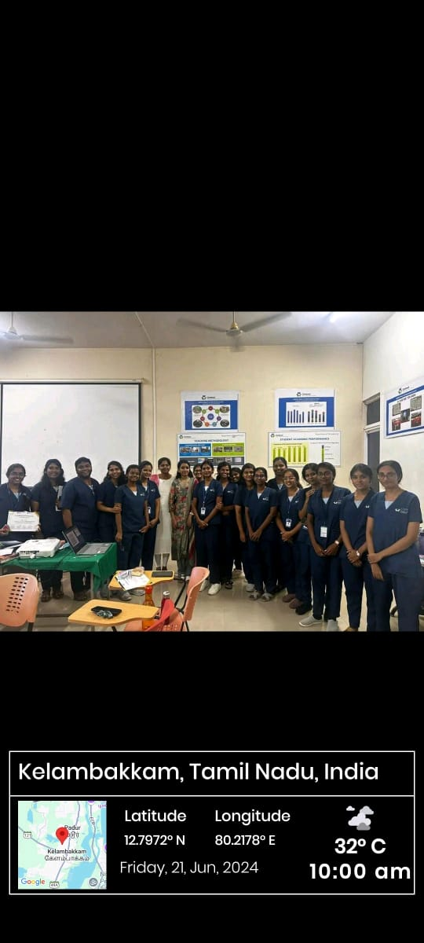

FEEDBACK ANALYSIS:

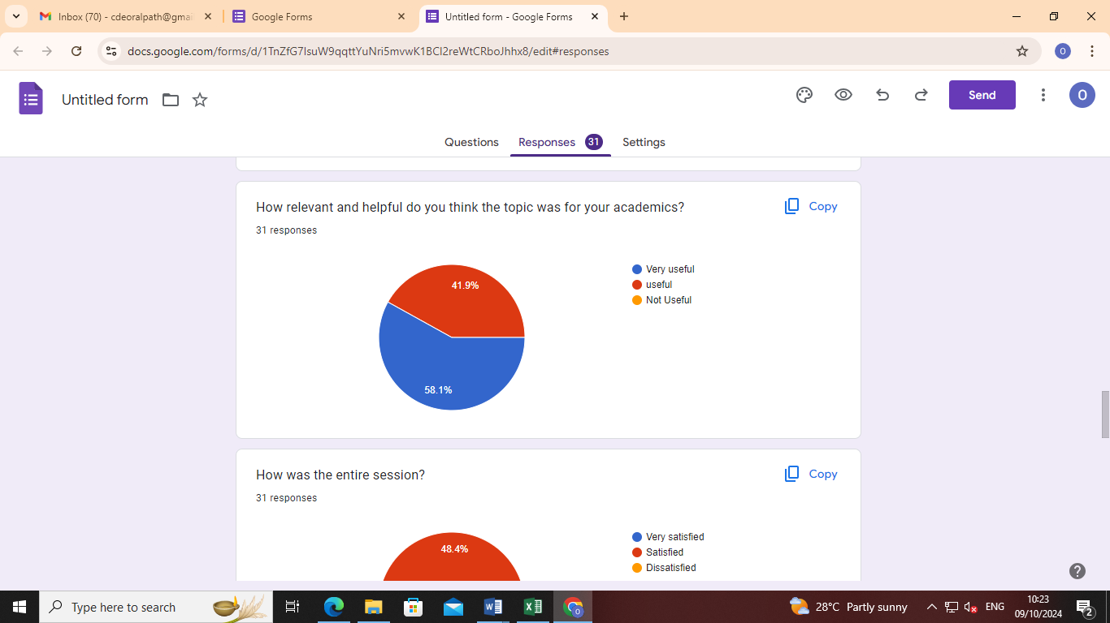

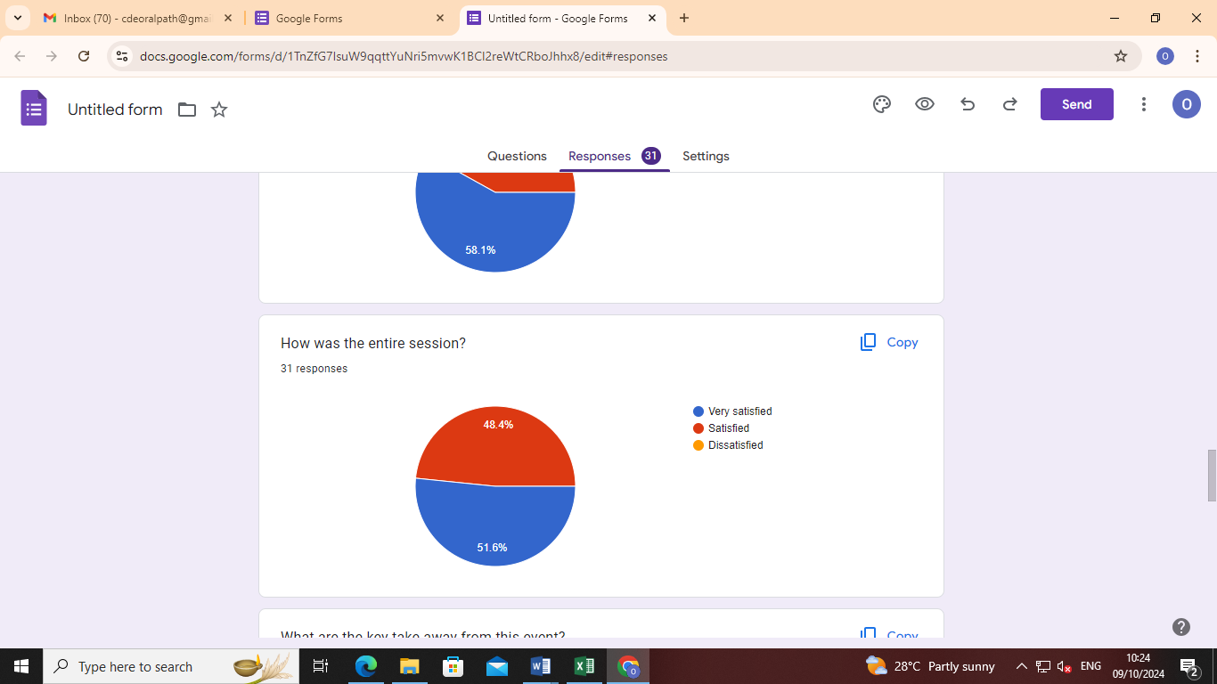

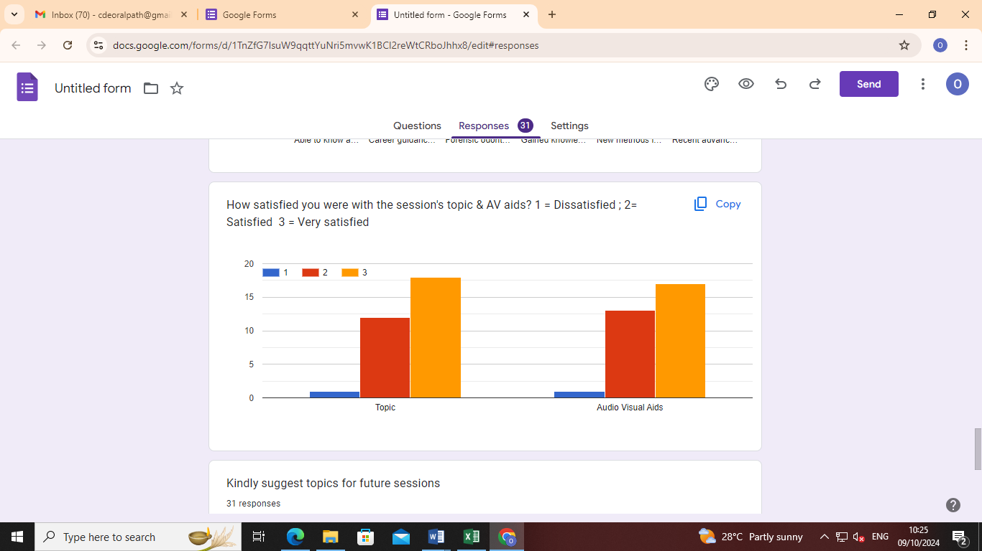

GUEST SPEAKER CERTIFICATES:

